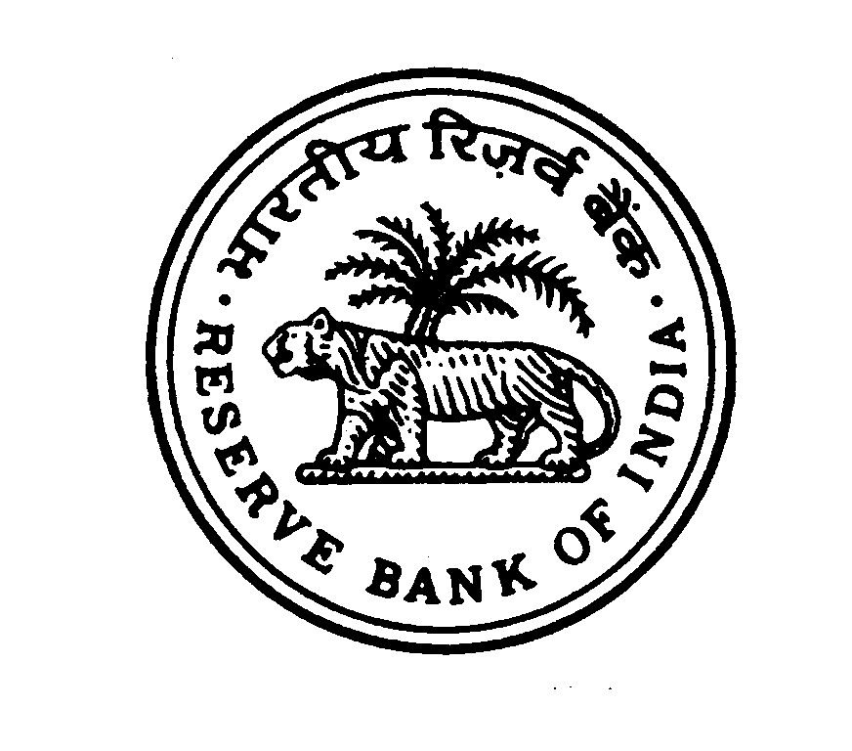**RESERVE BANK OF INDIA**

**PROTOCOL & SECURITY CELL**

**LUCKNOW**

**Notice for Empanelment of Contractors/ Suppliers for providing Non- Cleaning Materials and Garbage Bags for Reserve** **Bank of India at Lucknow**

The Reserve Bank of India, Lucknow intends to empanel suppliers & contractors for providing Non- Cleaning Materials and Garbage Bags at its office and residential buildings. The details of eligibility criteria and the application form are available on the corporate website of the Bank [www.rbi.org.in](https://rbi.org.in/home.aspx). Interested suppliers / contractors may visit “Tenders” link on RBI website [www.rbi.org.in](http://www.rbi.org.in) for full details and downloading the application form. Application forms to the eligible persons will also be issued free of cost from **December 16, 2023 to February 05, 2024** on working days from 1000 hrs to 1700 hrs by **Protocol & Security Cell, Reserve Bank of India, Lucknow - 226010**. Suppliers / contractors already empaneled with other departments at RBI Lucknow are also required to submit applications afresh.

Duly completed application in sealed cover super-scribing **“Empanelment of Contractors/ Suppliers for (a)Non-Cleaning Materials (b) Garbage Bags (c) Both (Tick once category)”** should be submitted to the above address on or before 1500 hrs **February 05, 2024.**

The Bank reserves the right to reject any or all the applications without assigning any reason thereof.

Regional Director

Reserve Bank of India

Lucknow (Uttar Pradesh)