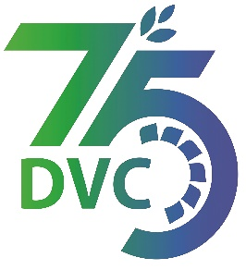 **damaooadr GaaTI inagama**



Damodar Valley Corporation

संविदा और सामग्री विभाग

**Contracts and Materials Department**

डीवीसी टावर्स; तृतीय तल; वीआइपी रोड; कोलकाता-७०००५४ टेली फ़ैक्स न०-०३३-२३५५-२९३६

**DVC Towers; 3rd Floor; VIP Road, Kolkata – 700054 Tele fax No.-033 – 2355 –2936.**

**E-Tender Notice**

Damodar Valley Corporation invites online bids (**Open Tender with E-Reverse Auction**) from the eligible bidders for:

|  |  |  |
| --- | --- | --- |
| REFERENCE NO. | Description of item | Tender Downloading Period and Time |
| **DVC NIT NO:**- DVC/Tender/Head Quarter/Distribution-HQ/CMM/Works and Service/00003/Capital Dated 17/07/2023**.** ***************************  CPPTender ID**:-**2023_DVC_161398_1 | Erection, Commissioning & Testing of twelve (12) nos. 33/11 KV E-House sub-station (Containerized s/s) for developing 11 KV infrastructure at prospective location in DVC Command Area and construction of Two (2) nos. Central Control Room on Turn Key Basis | From:  18.07.2023 at 12.00 Hrs.(IST)  To  16.08.2023 at 12.00 Hrs.(IST) |

For further details and to participate in tender, please log on:

<https://etenders.gov.in/eprocure/app>

Note: For any Technical Queries call:- **0120-4200 462, 0120-4001 002, 0120-4001 005,**

**0120-6277 787.**

**E-Mail Support:** **Technical - support-eproc(at)nic(dot)in**