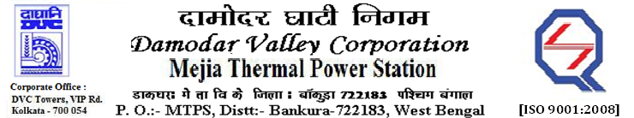

**Phone No.: 03241**- **263038FAX: 03241-262287**

**E-Tender Notice**

Damodar Valley Corporation invites online bids with **On-line reverse auction (RA)** from eligible bidders for:

|  |  |  |  |
| --- | --- | --- | --- |
|  | NIT No. | Description of Job (s) | Tender Downloading Period & Time |
| 1*.* | MT/O&M/QSF-05-06-12/22-23/DBN (335)/141 dtd.10/11/2022 | ARC for maintenance of HT & LT Switch Gear, HT& LT Motors, HT& LT Cables, LT Bus Duct, Distribution Transformers etc. under “BTG, entire Coal Mill area, entire Ash package, Plant Water system including Barrage Intake and BOP area of U#1 to 6. | From 11:05Hrsof 12.11.2022 to  11.00 Hrs. of 08.12.2022 |

For further details and to participate in the tender, please log on to DVC Website [www.dvc.gov.in](http://www.dvc.gov.in), and <https://etenders.gov.in/eprocure/app>

*Note*: e-procurement Helpdesk No. 9831683690 / Mob:8240124812 may please be contacted.

Your faithfully,

Sd/-

Smt. Archana Lakra,

SE (C&M), Works, MTPS, DVC,

[archana.lakra@dvc.gov.in],

Mob: 9432861534