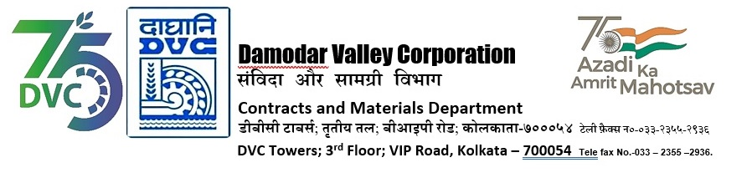

|  |  |  |
| --- | --- | --- |
| **DAMODAR VALLEY CORPORATION**  **Contracts and Materials Department**  **DVC Towers; 3rd Floor; VIP Road, Kolkata – 700054**  **Tele fax No.-033 – 2355 –2936.** | | |
| **NO. DVC/Tender/Head Quarter/OS & U/CMM/Supply/00062/REV_1 dated 11/01/2024** | | |
| **E-TENDER NOTICE**  **“THROUGH GeM PORTAL ONLY”**   |  |  |  | | --- | --- | --- | | **Sl. No.** | **NIT No. & Description of Work** | **Tender Downloading Time & Period** | | 1. | **NIT/Bid No. :**  GEM/2023/B/4401481 Dated: 11-01-2024  **Tender Description :**  Centralized Procurement of Liquor Ammonia (25% - Analytical Reagent Grade) conforming to IS 799 (Latest) for a period of six (06) months for different field formations of DVC through GeM | From **11/01/2024 at 17:00 Hrs. (IST) to 08/02/2024 at 12:00 Hrs. (IST)** | | For further details and participate in the tender, please log https://gem.gov.in/  or www.dvc.gov.in [For view only]  for any help regarding the above tender contact to  GeM Customer care at <https://gem.gov.in/contactUs> | | | | | |
|  |