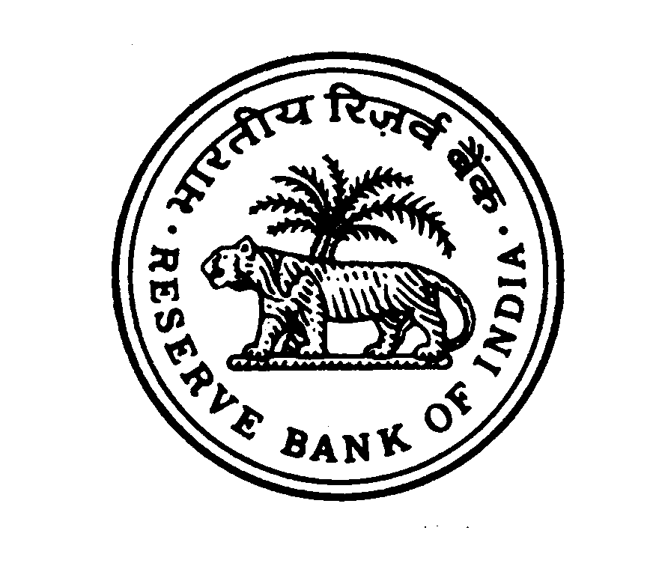
RESERVE BANK OF INDIA
PROTOCOL & SECURITY CELL
LUCKNOW

Notice for Empanelment of Contractors/ Suppliers for providing Non- Cleaning Materials and Garbage Bags for Reserve Bank of India at Lucknow

The Reserve Bank of India, Lucknow intends to empanel suppliers & contractors for providing Non- Cleaning Materials and Garbage Bags at its office and residential buildings. The details of eligibility criteria and the application form are available on the corporate website of the Bank www.rbi.org.in. Interested suppliers / contractors may visit “Tenders” link on RBI website www.rbi.org.in for full details and downloading the application form. Application forms to the eligible persons will also be issued free of cost from December 16, 2023 to February 05, 2024 on working days from 1000 hrs to 1700 hrs by Protocol & Security Cell, Reserve Bank of India, Lucknow - 226010. Suppliers / contractors already empaneled with other departments at RBI Lucknow are also required to submit applications afresh.

Duly completed application in sealed cover super-scribing “Empanelment of Contractors/ Suppliers for (a)Non-Cleaning Materials (b) Garbage Bags (c) Both (Tick once category)” should be submitted to the above address on or before 1500 hrs February 05, 2024.

The Bank reserves the right to reject any or all the applications without assigning any reason thereof.

Regional Director
Reserve Bank of India
Lucknow (Uttar Pradesh)

