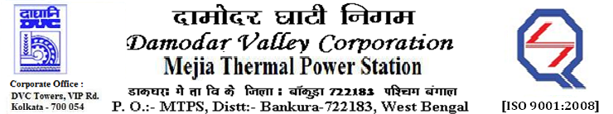
Phone No.: 03241- 263038FAX: 03241-262287

E-Tender Notice

Damodar Valley Corporation invites online bids with On-line reverse auction (RA) from eligible bidders for:

 | NIT No. | Description of Job (s) | Tender Downloading Period & Time
1. | MT/O&M/QSF-05-06-12/22-23/DBN (335)/141 dtd.10/11/2022 | ARC for maintenance of HT & LT Switch Gear, HT& LT Motors, HT& LT Cables, LT Bus Duct, Distribution Transformers etc. under “BTG, entire Coal Mill area, entire Ash package, Plant Water system including Barrage Intake and BOP area of U#1 to 6. | From 11:05Hrsof 12.11.2022 to  11.00 Hrs. of 08.12.2022

For further details and to participate in the tender, please log on to DVC Website www.dvc.gov.in, and https://etenders.gov.in/eprocure/app

Note: e-procurement Helpdesk No. 9831683690 / Mob:8240124812 may please be contacted.

Your faithfully,

Sd/-
Smt. Archana Lakra,
SE (C&M), Works, MTPS, DVC,
[archana.lakra@dvc.gov.in],
Mob: 9432861534

