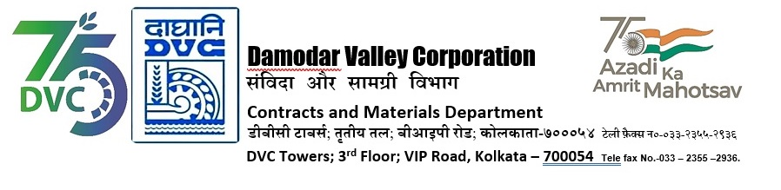
DAMODAR VALLEY CORPORATION
Contracts and Materials Department
DVC Towers; 3rd Floor; VIP Road, Kolkata – 700054
Tele fax No.-033 – 2355 –2936.

NO. DVC/Tender/Head Quarter/OS & U/CMM/Supply/00062/REV_1 dated 11/01/2024
E-TENDER NOTICE

“THROUGH GeM PORTAL ONLY”

Sl. No. | NIT No. & Description of Work | Tender Downloading Time & Period
1. | NIT/Bid No. :  GEM/2023/B/4401481 Dated: 11-01-2024  Tender Description :  Centralized Procurement of Liquor Ammonia (25% - Analytical Reagent Grade) conforming to IS 799 (Latest) for a period of six (06) months for different field formations of DVC through GeM | From 11/01/2024 at 17:00 Hrs. (IST) to 08/02/2024 at 12:00 Hrs. (IST)
For further details and participate in the tender, please log https://gem.gov.in/
or www.dvc.gov.in [For view only]
for any help regarding the above tender contact to
GeM Customer care at https://gem.gov.in/contactUs

