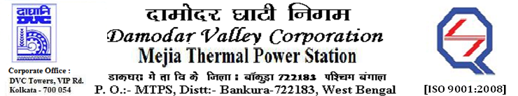
Phone No.: 03241- 263038 FAX: 03241-262287

E-Tender Notices

Damodar Valley Corporation invites online bids with On-line reverse auction (RA) from eligible bidders for:

 | NIT No. | Description of Job (s) | Tender Downloading Period & Time
1. | MT/O&M/QSF-05-06-02/22-23/SN(016)/134 dated 25/10/2022 | Overhauling of boiler and auxiliaries of Unit#8, MTPS, DVC.
  From 18.45 Hrs. of 25.10.2022 to 09.00 Hrs. of 21.11.2022

For further details and to participate in the tender, please log on to DVC Website www.dvc.gov.in, and https://etenders.gov.in/eprocure/app
Note: e-procurement Helpdesk No. 9831683690 / Mob: 8240124812 may please be contacted.

Your faith fully,

Sd/-

Shri Pradip Kumar Ghosh,
SE (Tech), MTPS, DVC,
[pradip.ghosh@dvc.gov.in],
Mob: 9434745726
Date: 26.10.2022

