
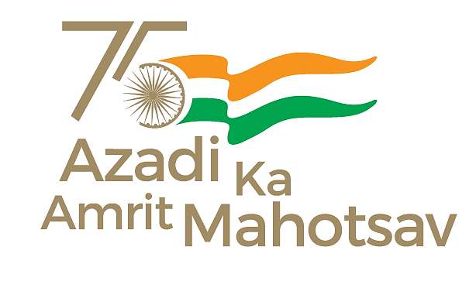
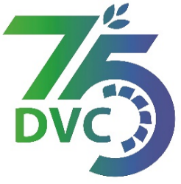
Damodar Valley Corporation
संविदा और सामग्री विभाग
Contracts and Materials Department
डीवीसी टावर्स; तृतीय तल; वीआइपी रोड; कोलकाता-७०००५४ टेली फ़ैक्स न०-०३३-२३५५-२९३६
DVC Towers; 3rd Floor; VIP Road, Kolkata – 700054 Tele fax No.-033 – 2355 –2936.

DAMODAR VALLEY CORPORATION
Contracts and Materials Department
DVC Towers; 3rd Floor; VIP Road, Kolkata – 700054
Tele fax No.-033 – 2355 –2936.

NO. DVC/Tender/Head Quarter/FUEL 1/CMM/Works and Service/00028 dated 08/08/2023
E-TENDER NOTICE

“THROUGH GeM PORTAL ONLY”

Sl. No. | NIT No. & Description of Work | Tender Downloading Time & Period
1. | NIT/Bid No. : GEM/2023/B/3718184 Dated 08/08/2023  Description : Loading of coal at colliery/colliery Pit head/stack yard and Transportation of Coal by Road with dumpers/ tippers/ hyva from different collieries/ coal washeries of BCCL/ECL/ CCL/any other coal company to RTPS Coal yard under distance Slab-A (31-70 Km) and unloading thereof at RTPS Coal Yard  .  . | From 08/08/2023 at 14:00 Hrs. (IST) to 05/09/2023 at 12:00 Hrs. (IST)
For further details and participate in the tender, please log https://gem.gov.in/
or www.dvc.gov.in [For view only]
for any help regarding the above tender contact to
GeM Customer care at https://gem.gov.in/contactUs

