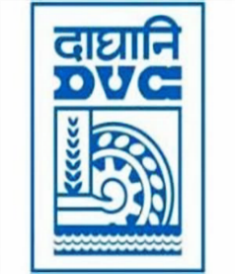
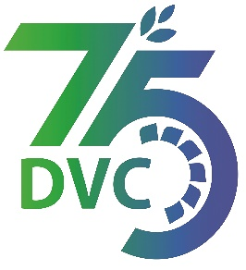
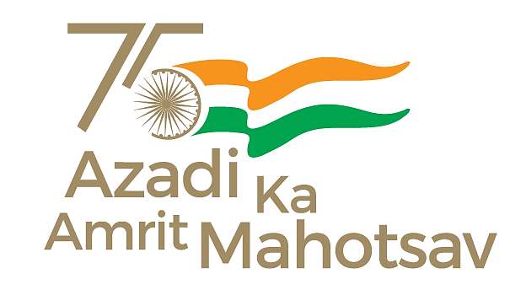
Damodar Valley Corporation
संविदा और सामग्री विभाग
Contracts and Materials Department
डीवीसी टावर्स; तृतीय तल; वीआइपी रोड; कोलकाता-७०००५४ टेली फ़ैक्स न०-०३३-२३५५-२९३६
DVC Towers; 3rd Floor; VIP Road, Kolkata – 700054 Tele fax No.-033 – 2355 –2936.

E-Tender Notice
Damodar Valley Corporation invites online bids through Corrigendum- I (Open Tender with E-Reverse Auction) from the eligible bidders for:
REFERENCE NO. | Description of item | Tender Downloading Period and Time
DVC NIT NO: - DVC/Tender/Head Quarter/SPE/CMM/Supply/00057/Capital dated 05.12.2024 ***************************  CPP Tender ID: - 2024_DVC_218008_1 | Procurement of 02 nos. of 500 MVA, 400KV / 220KV / 33KV, 3- phase Auto-Transformers (ICT) | From:  03.01.2025 at 12:00 Hrs. (IST)  To  17.01.2025 at 12.00 Hrs. (IST)

For further details and to participate in tender, please log on:
https://etenders.gov.in/eprocure/app

Note: For any Technical Queries call: - 0120-4200 462, 0120-4001 002, 0120-4001 005,
0120-6277 787

E-Mail Support: Technical support- eproc@nic.in

