
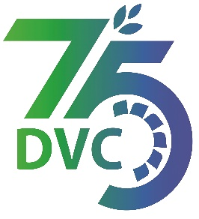
damaooadr GaaTI inagama

Damodar Valley Corporation
संविदा और सामग्री विभाग
Contracts and Materials Department
डीवीसी टावर्स; तृतीय तल; वीआइपी रोड; कोलकाता-७०००५४ टेली फ़ैक्स न०-०३३-२३५५-२९३६
DVC Towers; 3rd Floor; VIP Road, Kolkata – 700054 Tele fax No.-033 – 2355 –2936.

E-Tender Notice
Damodar Valley Corporation invites online bids (Open Tender with E-Reverse Auction) from the eligible bidders for:
REFERENCE NO. | Description of item | Tender Downloading Period and Time
DVC NIT NO:- DVC/Tender/Head Quarter/SPE/CMM/Works and Service/00070/Capital dated 07/02/2025. ***************************  CPP Tender ID:- 2025_DVC_226069_1 | ESTABLISHMENT OF 132KV(GIS)/33KV(AIS) SOLAR POOLING STATION AT MAITHAN FOR 234 MW FLOATING SOLAR (FSPV) PARK ALONG WITH THE CONSTRUCTION OF 132KV D/C LILO FROM MHS-SINDRI LINE.. | From:  07.02.2025 at 18.50 Hrs. (IST)  TO  07.03.2025 at 12.00 Hrs. (IST)

For further details and to participate in tender, please log on:
https://etenders.gov.in/eprocure/app

Note: For any Technical Queries call:- 0120-4200 462, 0120-4001 002, 0120-4001 005,
0120-6277 787.
E-Mail Support: Technical - support-eproc(at)nic(dot)in

