BY SPEED POST/FAX

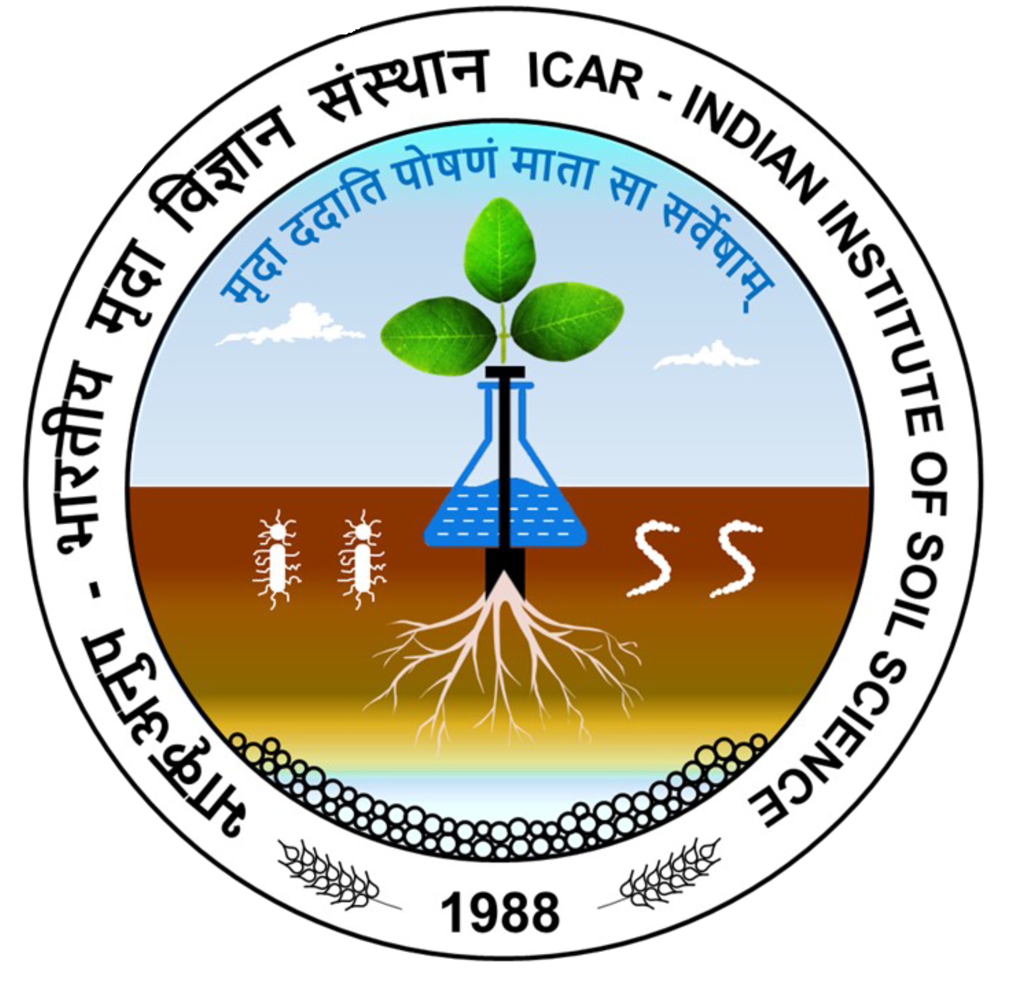
¼Hkk0d`0vuq0i0½ Hkkjrh; e`nkfoKkulaLFkku
uchckx] cSjfl;kjksM] Hkksiky& 462038
ICAR-Indian Institute of Soil Science
Nabibagh, Berasia Road, Bhopal – 462038 (M.P.)
Tel. No. (0755)2747375 EPABX:2730970/2734221 (Ext. No. 233 & 261) Fax. No. (0755) 2733310
F. No. 5-784/2021-22/P&S/IISS Dated: 06.09.2022

TENDER NOTICE

On behalf of the Director, ICAR-IISS, Bhopal, online Bid is invited through GeM portal vide bid no. GEM/2022/B/2493537 dated 02.09.2022 up to 27.09.2022 (03:00 PM) for supply of ICP-OES Spectrometer with Hydride Generator (01 no.). The detail of GeM bid is also available in the Institute website https://iiss.icar.gov.in.

Administrative Officer

