BY SPEED POST/FAX

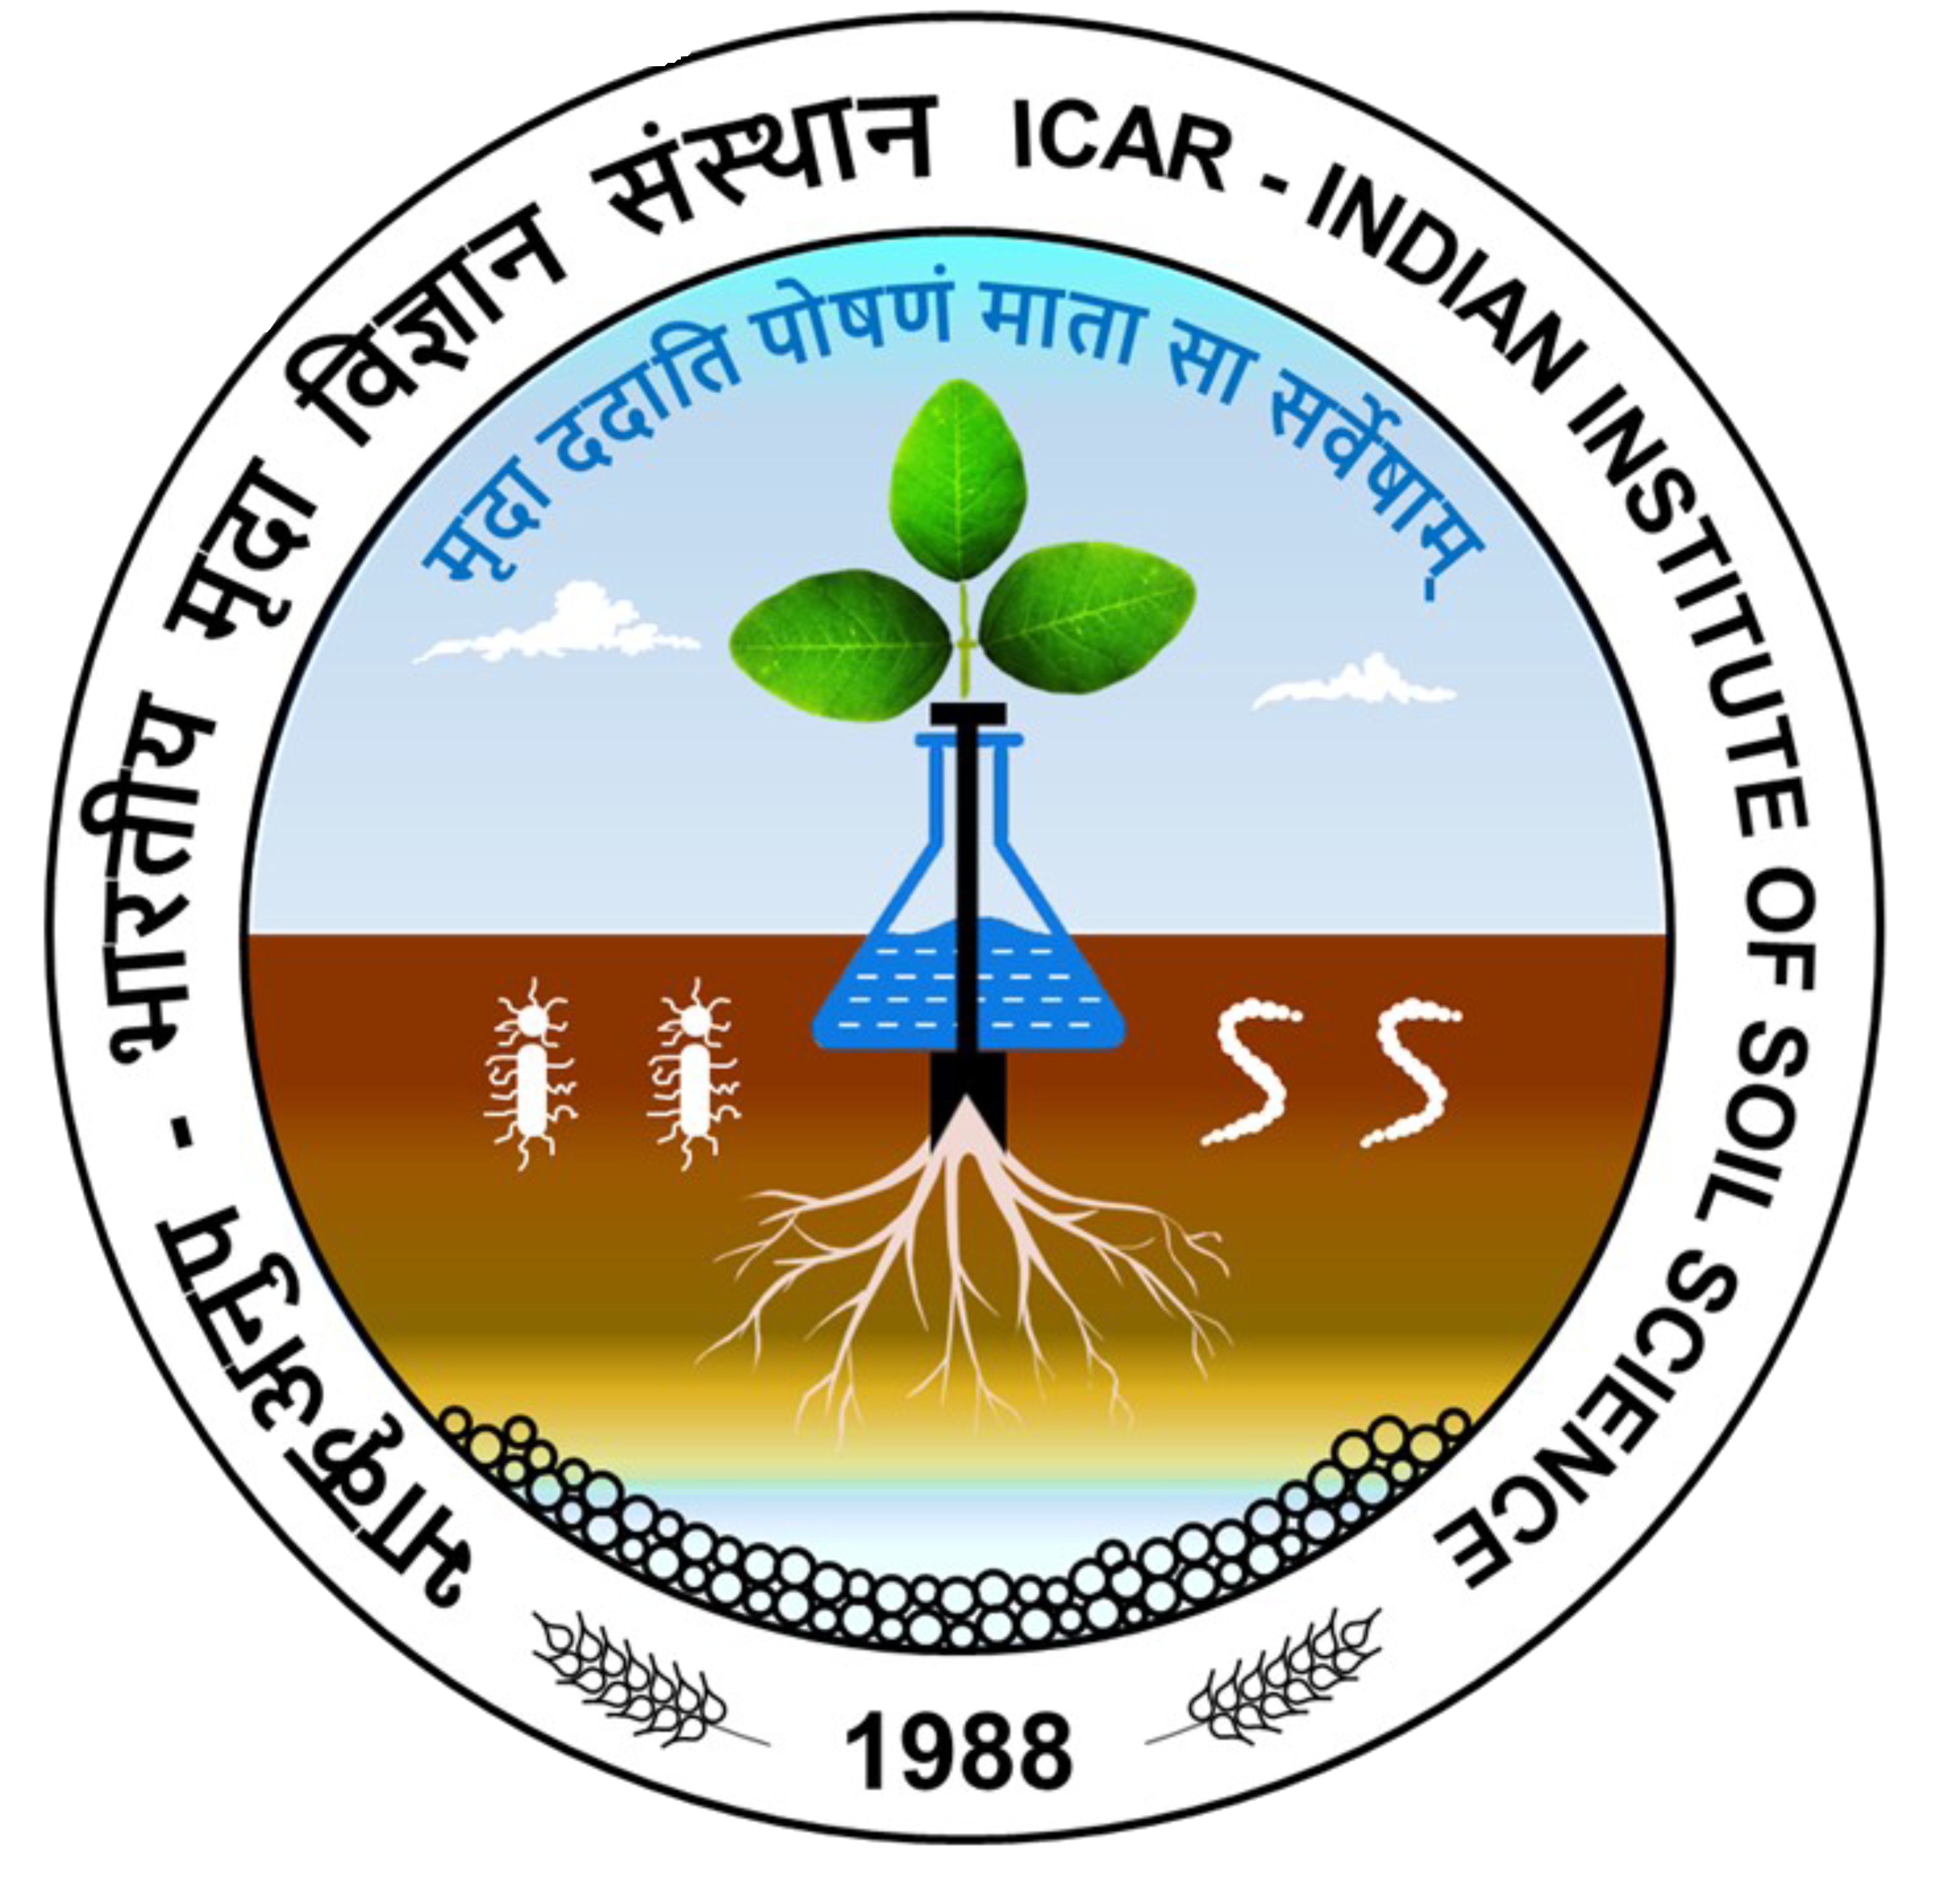
¼Hkk0d`0vuq0i0½ Hkkjrh; e`nk foKku laLFkku
uchckx] cSjfl;k jksM] Hkksiky & 462038
ICAR-Indian Institute of Soil Science
Nabibagh, Berasia Road, Bhopal – 462038 (M.P.)
Tel. No. (0755)2747375 EPABX:2730970/2734221 (Ext. No. 233 & 261) Fax. No. (0755) 2733310
F. No. 5-933/2023-24/P&S/IISS Dated: 20.07.2023

TENDER NOTICE

On behalf of the Director, ICAR-IISS, Bhopal, online Bid is invited through GeM portal vide bid no. GEM/2023/B/3712995 dated 20.07.2023 up to 10.08.2023 (05:00 PM) for supply of Fourier-Transform Infrared Imaging Microscope with all Accessories (01 no.). The detail of GeM bid is also available on the Institute website https://iiss.icar.gov.in.
Assistant Administrative Officer

