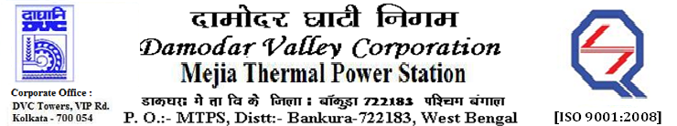
Phone No.: 03241- 263038 FAX: 03241-262287

E-Tender Notices

Damodar Valley Corporation invites online bids with On-line reverse auction (RA) from eligible bidders for:

 | NIT No. | Description of Job (s) | Tender Downloading Period & Time
1. | MT/O&M/QSF-05-06-01/22-23/GEM/2023/B/3020850/SN(024)/180 dated 01/02/2023 | ROUND THE CLOCK ANNUAL RATE CONTRACT (for 2 years) FOR MAINTENANCE OF COAL MILL INCLUDING ITS REJECTION SYSTEM ALONG WITH COAL FEEDER AND THEIR AUXILIARIES AND ASSOCIATED GATES, DAMPERS, PULVERIZED FUEL PIPING OF UNIT#7&8, DVC, MTPS (2X500 MW)
  From 15.40 Hrs. of 01.02.2023 to 16.00 Hrs. of 01.03.2022

For further details and to participate in the tender, please log on to DVC Website www.dvc.gov.in, and https://etenders.gov.in/eprocure/app
Note: e-procurement Helpdesk No. 9831683690 / Mob: 8240124812 may please be contacted.

Your faith fully,

Sd/-

Ms Archna Lakra,
SE (Tech), MTPS, DVC,
[archana.lakra@dvc.gov.in],
Mob: 9432861534
Date: 04.02.2023

