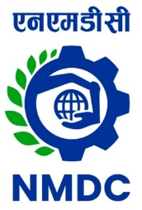
NMDC Limited
(A Government of India Enterprise)
‘Khanij Bhavan’, 10-3-311/A, Castle Hills,
Masab Tank, Hyderabad –500 028
Corporate Identity Number (CIN) - L13100TG1958GOI001674

EXPRESSION OF INTEREST

EOI No: HO(Contracts)/KM/SH/2024/201 Dated 03.04.2024

NMDC Limited, A “NAVARATNA” Public Sector Company under Ministry of Steel, Govt. of India, invites Expression of Interest (EOI) from experienced firms for identifying the interested parties for Transporting iron ore from Kumaraswamy Mine to Swamihalli Railway Siding (Karnataka) through Belt Conveyors and Stacking & Loading Rail Wagons on BOOM basis.

The EOI documents can be viewed and /or downloaded from 03.04.2024 to 29.04.2024 from following website links;

- NMDC website – https://www.nmdc.co.in /nmdctender/default.aspx
- Central Public Procurement portal – https://www.eprocure.gov.in/epublish/app and search EOI documents through EOI number

For accessing the EOI documents from NMDC web site for the first time; on-line registration is required as ‘New User’ in ‘Tenders’ section at website link https://www.nmdc.co.in/nmdctender/default.aspx of NMDC. The intending parties are required to visit the NMDC’s website and / or CPP Portal for corrigendum, if any, at a future date.

For further clarification, the following can be contacted –

General Manager (C, P & S), NMDC Limited, Hyderabad, Telephone No. 040 – 23532800, email: contracts@nmdc.co.in.

Executive Director (Works)

