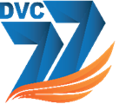
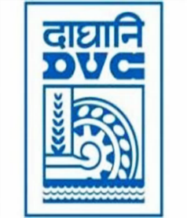
Damodar Valley Corporation
संविदा और सामग्री विभाग
Contracts and Materials Department
डीवीसी टावर्स; तृतीय तल; वीआइपी रोड; कोलकाता-७०००५४ टेली फ़ैक्स न०-०३३-२३५५-२९३६
DVC Towers; 3rd Floor; VIP Road, Kolkata – 700054 Tele fax No.-033 – 2355 –2936.

E-Tender Notice
Damodar Valley Corporation invites online bids (Open Tender with E-Reverse Auction) from the eligible bidders for:
REFERENCE NO. | Description of item | Tender Downloading Period and Time
DVC NIT NO: - DVC/Tender/Head Quarter/SPE/CMM/Supply/00060/Capital dated 25.03.2025  ****************************************  CPP Tender ID: - 2025_DVC_231137_1 | Procurement of 03 nos. of 31.5 MVA, 132/34.5KV Power Transformers | From:  25.03.2025 at 13:00 Hrs. (IST)  To  22.04.2025 at 13.00 Hrs. (IST) with Pre-Bid meeting on 07.04.2025 at 12:00 Hrs. through online mode through Microsoft Team

For further details and to participate in tender, please log on:
https://etenders.gov.in/eprocure/app

Note: For any Technical Queries call: - 0120-4200 462, 0120-4001 002, 0120-4001 005,
0120-6277 787

E-Mail Support: Technical support- eproc@nic.in

