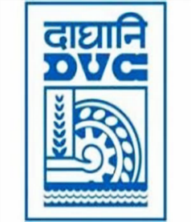
damaooadr GaaTI inagama
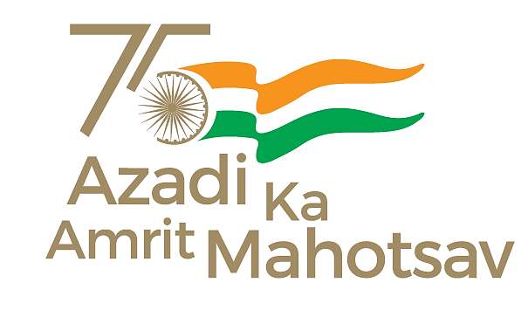
Damodar Valley Corporation
संविदा और सामग्री विभाग
Contracts and Materials Department
डीवीसी टावर्स; तृतीय तल; वीआइपी रोड; कोलकाता-७०००५४ टेली फ़ैक्स न०-०३३-२३५५-२९३६
DVC Towers; 3rd Floor; VIP Road, Kolkata – 700054 Tele fax No.-033 – 2355 –2936.

E-Tender Notice
Damodar Valley Corporation invites online bids in Open Tender from the eligible bidders for:
REFERENCE NO. | Description of item | Tender Downloading Period and Time
DVC NIT NO:- DVC/Tender/Head Quarter/SPE/CMM/Works and Service/00074/Capital dated 13/05/2025. ***************************  CPP Tender ID:- 2025_DVC_235296_1 | SUPPLY, ERECTION, TESTING & COMMISSIONING OF 220 KV 2ND BURNPUR S/C LILO LINE FROM 220 KV KALYANESWARI-MEJIA (L#240) LINE AS PART OF POWER SUPPLY AUGMENTATION SCHEME OF ISP. | From:  14.05.2025 at 16.00 Hrs. (IST)  TO  11.06.2025 at 12.00 Hrs. (IST)

For further details and to participate in tender, please log on:
https://etenders.gov.in/eprocure/app

Note: For any Technical Queries call:- 0120-4200 462, 0120-4001 002, 0120-4001 005,
0120-6277 787.
E-Mail Support: Technical - support-eproc(at)nic(dot)in

