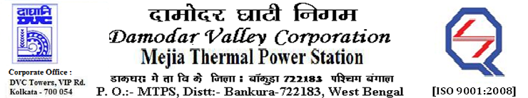
Phone No.: 03241- 263038FAX: 03241-262287

E-Tender Notices

Damodar Valley Corporation invites online bids with On-line reverse auction (RA) from eligible bidders for:

 | NIT No. | Description of Job (s) | Tender Downloading Period & Time
1. | MT/O&M/QSF-05-06-08/22-23/MB90 (ReT)/135 dtd. 01/11/2022 | Rate Contract for C&I system (field portion) of main plant along with its auxiliaries including works related to the C&I works of AHP & ETP (excluding Chlorination Plant) of Unit # 4 (210MW), Unit # 5 (250MW) & Unit # 6 (250MW) of MTPS, DVC for Two (02) years, on OTE basis with e-reverse auction.
  From 14.35 Hrs. of 02.11.2022 to 11.30 Hrs. of 28.11.2022

For further details and to participate in the tender, please log on to DVC Website www.dvc.gov.in, and https://etenders.gov.in/eprocure/app
Note: e-procurement Helpdesk No. 9831683690 / Mob:8240124812 may please be contacted.

Your faith fully,

Sd/-

Ms.Archana Lakra,
SE (Tech), MTPS, DVC,
[archana.lakra@dvc.gov.in],
Mob: 9432861534
Date: 07.11.2022

