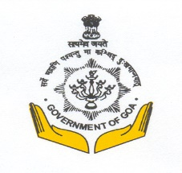
Department of Archaeology
Government of Goa
Ourem Road, Mala, Panaji, Goa, 403 001, India
No. 8/252/2020/DAA-55 | Date: 28/10/2022
(E-tendering)
Online tender Notice No. 8/252/2020/DAA-55 Date: 31/10/2022 has been issued.
Name of the work: RESTORATION OF CHAPORA FORT, ANJUNA BARDEZ GOA.
For eligibility and participation log on to https://eprocure.goa.gov.in
Sd/-
(Dr. Nilesh B. Fal Dessai)
Director of Archaeology

