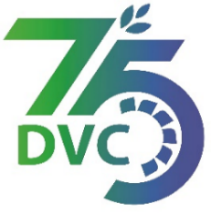

Damodar Valley Corporation

संविदा और सामग्री विभाग
Contracts and Materials Department
डीवीसी टावर्स; तृतीय तल; वीआइपी रोड; कोलकाता-७०००५४ टेली फ़ैक्स न०-०३३-२३५५-२९३६
DVC Towers; 3rd Floor; VIP Road, Kolkata – 700054 Tele fax No.-033 – 2355 –2936.

DAMODAR VALLEY CORPORATION
Contracts and Materials Department
DVC Towers; 3rd Floor; VIP Road, Kolkata – 700054
Tele fax No.-033 – 2355 –2936.

NO. DVC/Tender/Head Quarter/FUEL 1/CMM/Works and Service/00031 dated 13/09/2023
E-TENDER NOTICE

“Through CPPP website only”

Sl. No. | NIT No. & Description of Work | Tender Downloading Time & Period
1. | NIT/Bid No. : DVC/Tender/Head Quarter/FUEL/CMM/Works and Service/00031 Dated 13/09/2023  CPPP id: 2023_DVC_167603_1  Description : Rate Contract for Loading of coal at colliery/colliery Pit head/stack yard and Transportation of Coal by Road with dumpers/ tippers/ hyva from different collieries/ coal washeries of BCCL/ECL/ CCL/any other coal company to RTPS Coal yard under distance Slab-B (71-100 Km) and unloading thereof at RTPS Coal Yard, for a period of 240 Days | From 14/09/2023 at 09:00 Hrs. (IST) to 27/09/2023 at 16:00 Hrs. (IST)
For further details and participate in the tender, please log https://etenders.gov.in/eprocure/app
or www.dvc.gov.in [For view only]
for any help regarding the above tender contact to
Mr. Nawajesh Rahman (Mob. No. 03366072327, 9831683690)

