TRAFFIC DEPARTMENT
SALES WAREHOUSE/COMMERCIAL DIVISION
CHENNAI - 600 001
AUCTION CATALOGUE
E-Auction for the sale of 2 LOTS
E-AUCTION NO : SWH/E-AUCTION-I/009/2025/TC dt. 25/09/2025
MSTC REF : MSTC/SRO/CHENNAI PORT AUTHORITY/3/TRAFFIC DEPARTMENT /25-26/34607
(1) Lot 01/2018 - Stone aggregates in bulk (30-50Kgs)&
(2) Lot 04/2021 – Semi Coke .
INSPECTION DATE : From 26-09-2025 to 15-10-2025.
Auction Date and Time:16-10-2025 1100 Hrs to 1630 Hrs
Sl. No | Lot No. | Description of Cargo | Unit of Measure-ment | No. of. Packages / Weight | EMD Amount | Location
1 | 01/2018 | STONE AGGREGATES  (in bulk)  (30- 50 KGS.) | LOT  BASIS | 6492 Tons.  Approximately | Rs.2,00,000/- | SQ – II
2 | 04/2021 | Semi coke (in Bags | LOT  BASIS | 80Tons.  Approximately | Rs.30,000/- | JD V (south Godown)
Note : The weight indicated above are according to IGM filed by the respective agents in the year 2018 and 2021 respectively, by passage of time, due to wear and tear, the weight would certainly have marginally or sometimes substantially reduced. The intending purchaser shall inspect and evaluate the auction scheduled item in “as is where is condition ” and thereafter make bid offer. As per Clause-I of the conditions, CHPA will not take the responsibility with reference to Weights. Measurement. Quantity, Qualities. etc.,

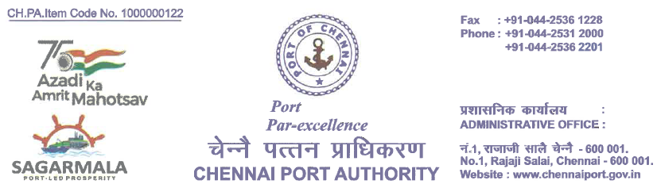
TRAFFIC DEPARTMENT
SALES WAREHOUSE/COMMERCIAL DIVISION
Auction : Conditions of Auction Sale for sale of un cleared cargo – 2 Lots.
[ (1)Semi Coke Under Lot NO.04/2021 and (2) Stone Aggregates in Bulk (each stone size 30-50 kg) – Boulders under lot No. 01/2018, vide E-auction No. SWH/E-Auction-1/009/2025/TC and MSTC Ref. No. MSTC/SRO/CHENNAI PORT AUTHORITY/3/TRAFFIC DEPARTMENT/25-26/34607
Date of Auction : 16-10-2025
Chennai Port Authority(ChPA) intends to dispose the unclaimed Cargo through E-auction.
Chennai Port Authority has appointed Service Provider – M/s. MSTC Ltd., as e-auctioneer
The auctioneer M/s. MSTC Ltd., will conduct e-auction through online as per the CHPA direction and as specified in the catalogue. E-auction starts at 11.00 hrs and closes at 16.30 hrs on the date of auction as specified in the auction catalogue.
Bidders desiring to participate in the e-auction shall approach the CHPA’s e-auctioneer M/s. MSTC Ltd., having address at ISPAT Bhawan, Kodambakam, Chennai-600 034.
All the un cleared cargo offered are in “as is where is condition” basis.
Inspection of lots can be done from 26-09-2025 to 15-10-2025 between 10.00 hrs and 17.00 Hrs on all working days ( Monday to Saturday), lunch break 13.00 -13.30 Hours .
The intending bidders can gain admission to the Harbour on days of inspection to inspect the materials. The bidders may obtain necessary Harbour Entry Permits , Please read Condition No. 6 for details :
Delivery period : 15 Days only (7 free days 8 days (with demurrage))

Validity : 180 Days

- The Bidders desirous to participate in the E-auction shall deposit PRE-BID –EMD(BID SECURITY) as per the table given below for the subject Lot with ChPA’s e-Auctioneer M/s.MSTC Ltd., Chennai through ON-LINE, prior to start of e-auction so as to become eligible for participation in this subject Lot. Bidders who have deposited Pre Bid- EMD ( Bid Security) alone will be allowed to participate in the e-auction.

Sl. No | Lot No. | Description of Cargo | Unit of Measurement | EMD Amount
1 | 01/2018 | STONE AGGREGATES  (30- 50 KGS.) | LOT  BASIS | Rs.2,00,000/-
2 | 04/2021 | Semi coke (in Bags) | LOT  BASIS | Rs.30,000/-

- After the closure of e-auction, the Pre-Bid- EMD ( Bid Security) of the highest bidders is to be sent to CHENNAI PORT AUTHORITY by the e-auctioneer(M/s. MSTC Ltd).
- Pre Bid- EMD (Bid Security) of unsuccessful bidders to be directly returned by the e-auctioneer (M/s. MSTC Ltd) to the respective unsuccessful bidders on the next day of closure of e-auction.

- Pre Bid- EMD (Bid Security) of the highest bidder will be adjusted only in final payment of sale value.
- Pre Bid- EMD (Bid Security) of the highest bidder will be forfeited if he fails to pay the sale value.
- ALL The LOTS shall be sold on LOT Basis.

Sd./-

Senior Deputy Traffic Manager

For Traffic Manager

SCHEDULE ‘A’

SALES WAREHOUSE/ COMMERCIAL DIVISION

TRAFFIC DEPARTMENT

AUCTION CATALOGUE

Un Claimed cargo

AUCTION DATE: 16-10-2025 AUCTION TIME: 11.00 AM.

-----------------------------------------------------------------------------------------------------------
- LOT NO. 01/2018 STONE AGGREGATES (in bulk) (30 – 50 Kgs)

LOCATION : SQ II wharf

GST 5 % ** Income Tax 1% CSD 5% (LOT BASIS)

Rate Shall be quoted in Lot Basis
Contact Person:
- Shri. Ramesh kumar, Section Supt., Mobile No. 9444260147.
- Shri. Lingannan, Section Supt., Mobile No. 9445213476.

--------------------------------------------------------------------------------------------------------------------

** Note : GST % given is only indicative, decision of Customs UCC Section is final

Contd..
SCHEDULE ‘A’ contd..

- LOT NO. 04/2021 SEMI COKE (IN BAGS )

LOCATION : JD V SOUTH SHED

GST 5 % ** Income Tax 1% CSD 5% (LOT BASIS)

Rate Shall be quoted in Lot Basis
Contact Person:
- Shri. Sathyanarayanan, Section Superintendent Mobile No. 9840142648.
- Shri. Adi Narayana Section Superintendent Mobile No. 9597623897.

** Note : GST % given is only indicative, decision of Customs UCC Section is final

---------------------------------------------------------------------------------------------------------------------

Sd./-

SENIOR DEPUTY TRAFFIC MANAGER

For TRAFFIC DEPARTMENT

SCHEDULE-B
ANNEXURE “A”
Sl.  No. | CONDITIONS OF AUCTION SALE
The Chennai Port Authority (ChPA)’s E-Auctioneer will conduct e-auction through online and the ChPA auction committee shall view the auction through online. The e-auction starts at 11.00 Hours and close at 16.30 Hours on the date of auction. If any bid is received during the last 8 minutes before scheduled closure of auction for any lot, its closing time will get automatically extended by 08 minutes from the time of last bid in order to give equal opportunities to all bidders. Bidding time for a particular lot will be either of the scheduled closing time (or) there will be a period of 8 minutes during which no bid has been received, whichever happens later. When the bidding for all lots in an e-auction closes, e-auction will be deemed as closed. The auctioneer shall declare whether the lots are confirmed / Subject to Approval (STA) / rejected.
ChPA Auction Catalogue: Auction catalogue contains Description, location and restrictions if any, for disposal with applicable rate of taxes, levies and other terms and conditions. The auctioneer will make necessary arrangements to float the auction particulars/catalogues in their website which may be downloaded by the on-line bidders to enable them to participate in the auction at their cost.
THE INTENDING PURCHASERS CAN BID THEIR RATES PER LOT / TON AND THE GOODS WILL BE DELIVERED ON LOT / TON BASIS ONLY.

The goods are to be taken on ‘as is where is’ basis. The Chennai Port Authority shall not take the responsibility with reference to Weights, Measurements, Quantities, Qualities, etc.
The particulars given in Schedule “A” are only to give an idea of the Goods offered and will not alter the “as is where is” nature of the offer.
Lots to be examined by the intending purchaser before bidding and to be taken with all faults and errors of description
The bidders are advised to quote the rates after inspection of the Goods at the site keeping in mind that the rates quoted are in “ as is where is ” Condition.
 | The bidders are advised to examine the goods carefully before making their offers and to quote the rates keeping in mind that the rates quoted are in ‘as is where is condition. No claims will be entertained on quantity, quality, etc. once the offers are made.
 | E-Auction will be conducted online by the Chennai Port Authority’s Auctioneer, M/s. MSTC Limited, Southern Regional Office, ISPAT BHAVAN, 3rd Floor, No.5, Kodambakkam High Road, Chennai – 600 034, through their website www.mstcecommerce.com.
 | The pre-bid EMD amount as per LOT description against Lot No. must be paid by the participating buyers through MSTC's e-commerce portal www.mstcecommerce.com,through Pay Pre-Bid EMD link provided in the buyer login page, buyer account only within Office hour at least one day before the date of e-auction and no other payment mode will be entertained.
The pre bid EMD of the unsuccessful bidder will be refunded back after completion of E-Auction by the Auctioneer to the respective bidder.
The Pre-Bid EMD (bid security) of the highest bidder will be transferred to ChPA by M/s. MSTC and the same will be adjusted in the final sale value.
Chennai Port Authority will not pay any interest to the bidder on the pre bid EMD amount/Balance amount/Refund amount or any deposits.
Inspection of materials – Any of the Bidders or their authorised representatives may inspect the goods offered before quoting and the same can be done during working hours, before auction, as per the inspection schedule specified in the auction catalogue. Temporary passes required for entering the Harbour for inspection of the goods offered can be obtained only through on line on payment basis. The intending bidders can gain admission to the Harbour on days of inspection to inspect the materials. The bidders may obtain necessary Harbour Entry Permits as follows:

(i) HEP request should be sent well in advance to COMMERCIAL Division by a letter or email addressed to dtmc@chennaiport.gov.in with details such as (i) Firms Name (ii) Mobile No. (iii) Email address (iv) Purpose with Authority reference of e-auction/Delivery order etc., (v) HEP for No. of Persons / Vehicles / Drivers. (vi) MSTC Ltd issued ID card copy

(ii) On receipt of above details to dtmc@chennaiport.gov.in, Commercial Division will process the request for Harbour Entry Permit. A message with a link and gate pass-ID will be sent to the registered e-mail automatically. By using the link received the requisite documents are to be scanned and uploaded duly entering the date of HEPs required with No. of persons/vehicle/drivers and making necessary payment. After processing the request, approval message will be sent again to Firms E-mail address from O/o Traffic Manager (Single window Erstwhile Pass Section).

(iii) Again the link in your e-mail may be utilised for taking printout copy of
Harbour Entry permit with QR Code for entering inside Harbour premises.

The person on whose name the passes are requested should be identified by the bidders and bidders are only responsible for any misuse of Harbour entry pass by the holder of the pass.
The successful bidder should also obtain HEP on payment for clearing the goods.
Temporary passes and vehicle’s permit required for clearing the goods sold in the auction can be had on payment and the procedure may be followed (The delivery will be effected only on completion of necessary formalities like payment of full sale value including Income Tax, GST, etc.,).
Confirmation of lot
All lots to be sold in the e-auction are subject to approval of the Commissioner of Customs as per the provisions under sec.48 of the Customs Act, 1962 and Circular No.49-2018 dt. 3.12.2018 issued by the CBIT and Customs as amended/revised from time to time.
The Rate Quoted by the bidders shall be valid for a period of 180 Days from the Date of closure of E-Auction.
Note : In case the entire process of auction is not concluded within 180 days of the commencement of auction, the custodian namely Chennai Port Authority shall inform the bidder about further extended time which may be required to conclude the auction process. Where ever, the bidder indicates his unwillingness to wait further, his successful bid will be cancelled and the earnest money, if any deposited with the custodian by the bidder will be returned to the bidder under intimation to Customs. Otherwise, the auction process shall be concluded within the extended time conveyed to the bidder.
(A) All lots sold in the e-auction are on ‘SUBJECT TO APPROVAL (STA) BASIS. Whenever the highest bid (H-1 bid) is acceptable on STA basis, depending upon the reserve price fixed by the ChPA, after closure of the e-auction, sale intimation letter will be issued automatically by email to the respective highest bidder informing him that his bid has been accepted on STA basis. Bidders must, therefore keep a watch on their incoming e-mail.
(B) For all Lots accepted by ChPA on STA basis, ChPA shall take action to obtain the approval of the Jurisdictional Commissioner of Customs. In respect of the lots for which approval has been received from the Commissioner of Custom, sale order will be issued through MSTC. The lots for which approval has not been given by customs shall be rejected and their pre-bid EMD amount shall be refunded without any interest.
 | The GST and Income Tax as applicable will be levied additionally as per rules in force.
PAYMENT TERMS:-
The Balance amount of sale value, including GST, Income Tax and Clearance Security Deposit, ie., after deducting Pre-bid EMD shall be paid within 10 Calendar Days from the date of sale order (including the date of Sale Order) through RTGS/NEFT to the below mentioned account of ChPA
NAME : The Chairman, CHENNAI PORT AUTHORITY
BANK : STATE BANK OF INDIA
BRANCH :CORPORATE ACCOUNTS GROUP (CAG BRANCH),
ACCOUNT : 1088 590 4367
IFS Code : SBIN 0009999
MICR CODE : 600 002 098
ADDRESS : 3RD FLOOR, SIGAPI ACHI BUILDING,
18/3, RUKMANI LAKSHMIPATHY SALAI
EGMORE, CHENNAI 600 008.
The details of payment viz., UTR No. Amount Paid, Date of payment, Bank and Branch, Mode of Payment NEFT/RTGS shall be sent to the Traffic Manager or any designated officer in this regard immediately after making payment and confirmation of payment shall be obtained.
ALTERNATIVELY
The bidder can also make payment of the balance amount through demand draft drawn on any scheduled commercial banks payable at Chennai in favour of Chairman, Chennai Port Authority payable at Chennai. The demand draft along with a covering letter containing details of lot for which payment has been made shall be sent to traffic department(sales warehouse) The traffic department will check the details of lots, date of e-auction, balance amount payable, etc., and if found correct will make an endorsement to AM(cash) for accepting the payment. Thereafter the bidder shall deposit the DD along with the covering letter, in the cash section of Finance department and obtain a Receipt for payment. A copy of the Receipt will be sent to Traffic department by Finance department for taking further action.
Delayed Payment :
In case of delay, the late payment charges @1% per week or part thereof on the total sale value will be charged up to a maximum period of two weeks only and thereafter, the EMD will stand forfeited without any notice. In case the last date for payment happens to be Holiday for ChPA or Banks, the next working day will be taken as the last date for payment without late payment charges. The bidders to note that balance payment shall be made directly to ChPA’s A/C as per details given above and not to MSTC. ChPA will not consider any payment received from MSTC in this regard.

DELIVERY ORDER :
After receipt of 100% sale value of the lot including GST, Income Tax and Clearance Security Deposit(5%), ChPA shall file B/E (Bill of Entry) with customs for clearance of the goods as per the provisions of the Customs Act 1962.
After assessment of customs duty by the proper officer, ChPA will make payment of the customs duty and obtain Out Of Charge order(OOC) from the customs.
On receipt of Out of Charge order from the Customs, Delivery Order will be issued by ChPA within 3 working days.
Bidders to note that getting out of charge from customs is completely dependent on Customs formalities. ChPA shall not be held responsible for any delay in issuing out of charge by Customs. During this period the amount paid by the bidders towards EMD, Balance Sale Value, etc., shall not attract any interest.
The Goods sold shall be delivered by the concerned Traffic Supervisory staff on production of delivery order by the buyer. Area Delivery Clerks shall arrange to issue VEHICLE TICKETs for the removal.
Goods sold in Auction shall be allowed SEVEN free days AS PER SCHEDULE 3.3.1, Sl. No.1(ii) of scale of rates as Revised/ Amended from time to time.
If the goods are not cleared within the stipulated free period, Demurrage charges shall be applicable as per clause 3.3.2 of the existing Scale of Rates, as revised/amended time to time
Note : Free period of seven working days shall count from the date of DELIVERY ORDER ( Excluding the date of Delivery Order)
The Delivery of Goods covered in Schedule “A” of the Auction Catalogue, during the free period and additional period, should be carried out from 0600 Hours to 0600 Hours on all days. [ 24 Hours, Round the Clock]
For payment of demurrage, In case of delivery is to be taken on Saturday, Sunday or Port Holidays, the bidder shall arrange to make payment of demurrage or any other dues within the working days of ChPA Administrative office, so as to effect delivery on Saturday, Sundays and Port holidays
 | The Purchasers are distinctly warned that if the goods are not cleared within EIGHT days from the date of expiry of free period, the sale of lot shall stand cancelled and the EMD and Bid amount will be forfeited. The bidder will have no claim whatsoever over the material and the same will be sold either privately or by Public Auction or E-Auction. The first purchaser will in such a situation be held liable for any loss arising from such resale and will forfeit any advances together with auctioneer’s commission.
All Risks to the Buyer.
The Goods shall remain, in every aspect, at the risk of the buyer from the time of acceptance of his offer and must be removed within the free period of Seven working days from the date of confirmation of sale at the purchaser’s expenses. Chennai Port Authority will not undertake any liability whatsoever for the safe custody, protection or preservation after the sale has been confirmed. Lots are put up for sale subject to change by nature’s wear and tear. No complaint regarding the quality or description of the Goods sold will be entertained once the bid has been accepted.
If the bidder withdraws his offer or fails to deposit the amount of the sale, offered Bid Security (Earnest Money Deposit) will be forfeited and his offer will be cancelled besides recording his unsatisfactory performances or action will be taken as deemed fit.
 | The Chennai Port Authority shall reserve the right to withdraw any of the items notified for sale without assigning any reason for such withdrawals. However, if any payment has been made, it would be refunded.
 | The Chennai Port Authority shall reserve the right to take such action against the defaulting bidder as deemed fit by the Authority and/or can debar the said bidder from bidding in the current and/or future auctions also.
 | If any goods are not sold in the auction for which they are listed, they will be included for sale on the succeeding sale by Tender or in Public Auction.
 | Goods advertised for sale will not be withdrawn by the Chennai Port Authority, except on payment of sufficient deposit by the concerned Importer to cover the Harbour dues, Demurrage charges / other charges due thereon and with the due permission of Jurisdictional Commissioner of Customs
 | The Chennai Port Authority reserves the right to amend and modify ‘Terms and Conditions’ and announce the same if need be while the auction is in progress or prior to commencement of Auction.
 | Cutting permission will be granted to successful bidder for the goods sold on lot basis subject to written permission from the Traffic Manager and ChPA Fire Officer where ever applicable. No cutting permission will be granted for the goods sold on Weighment basis lot.
 | Bidders who are participating in the e-auction shall contact Traffic Manager, CHENNAI PORT AUTHORITY for any clarifications and the clarification furnished there by will alone be binding and final. The clarification if any given by the ChPA appointed e-auctioneer., shall not be binding on the CHENNAI PORT AUTHORITY in any respect.
 | The goods should be removed from the Harbour premises within the time period prescribed above for confirmed lots from the date of issue of delivery order, by hiring the cranes on their own.
 | The Bidder shall use their own tools for the removal of goods sold and shall hold the Board indemnified in respect of any damage or injury caused to any of the employees or any other person and property during the execution of works.
 | The purchaser should also clearly note that the goods purchased in auction and taken delivery from the Area under official gate pass should on no account be kept within the Harbour premises.
 | The Responsibility of the ChPA seizes once the goods are sold.
 | The Bidder should ensure that the ChPA’s properties are not damaged during the course of removal of the goods, failing which the cost of rectifying the damage will be recovered from the amount deposited in the ChPA as Bid Security (Earnest Money Deposit). He shall observe the Dock Safety Regulations and such other Regulations in force and shall hold the Board indemnified, if any violation occurs. He will also be responsible for the discipline of the workers employed by him within the Harbour premises.
 | The Bidder shall confirm to and comply with regulations and Bye-laws of the State or Central Government or of the Board and of all other local authorities such as Corporation of Chennai, The Tamil Nadu Electricity Board, the Government Customs and Police Departments, Fire Services, the Provisions contained in the various Labour Acts enacted by the State Legislature and the Central Parliament in force and the Rules made there-under including those under the Minimum Wages Act, the Indian Electricity Act and Rules framed under it, Workmen’s Compensation Act, Provident Fund Regulations Act, Employees Provident Fund Act 1961 and the schemes made under the said Act. Health and Sanitary arrangements for Workers etc., and the Contract Labour (Regulations and Abolition) Central Rules 1971 etc., for the Welfare and protection of Workers or for the safety of the Public and other insurance Provisions.
 | The Bid is liable for cancellation, if either the Bidder himself or any of his employees is found to be a person who has held a Class-I Post under the Board immediately before retirement and has within Two years of such retirement accepted without obtaining the prior permission of the Board or the Chairman as the case may be, an employment as Bidder in connection with the execution of Public Works or as an employee or such Bidder.
 | The Board shall not be liable for the failure of the Bidder in conforming to the provisions of the Acts, Rules, Regulations referred to in the above para and in case of any contravention of the Provisions of the Acts, Rules, Regulations etc., the Bidder shall keep the Board indemnified against any loss and damages in the event of any action being taken for contravention.
 | If any Foreigner is employed by the Bidder to work within the Harbour premises, the Bidder shall ensure that such a Foreigner possesses the necessary special permit issued by the Civil Authority in writing and also to comply with the instructions issued therefore from time to time. In the event of any lapse in this regard on the part of such Foreigner the Bidder shall be personally held responsible for the lapse and the Board shall not be liable in any event.
 | If any Auction terminated on account of failure of the Bidder to comply with the above clause the Board shall be entitled to recover from the Bidder such damages as may be determined by the Traffic Manager, with due regard to the inconvenience caused to the ChPA on account of such termination without prejudice to the ChPA’s right to proceed against such Bidder.
 | The Bidder shall be solely responsible for reporting to the Board and Police Departments, Security Force immediately regarding any serious or fatal accidents at any place belonging to the Board including premises leased by the Board, to any of their employees/workmen engaged by him.
 | While evaluating Tenders, regard would be paid to the National Defence and Security considerations
 | In the event of any disputes or differences in connection with the E-auction, the same shall be settled asper the Indian law in the Civil Court Jurisdiction of CHENNAI CITY only.

Sd./-

Sr. Deputy Traffic Manager

For TRAFFIC MANAGER
PHOTO IMAGE OF LOT NO. 01/2018,
STONE AGGREGATES (30-50 KG.), IN BULK ,
Country of origin : INDIA Exporter : MATHI AGENCY
Weight : 6492 Tons (approx.) To be sold on lot basis

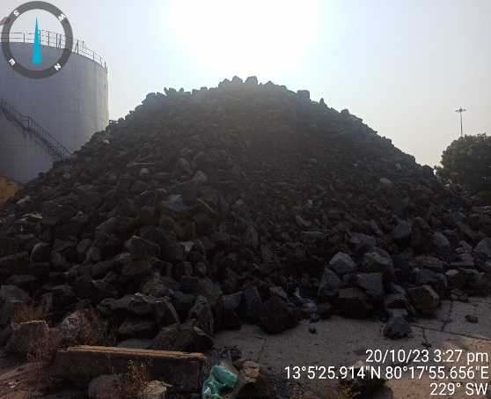
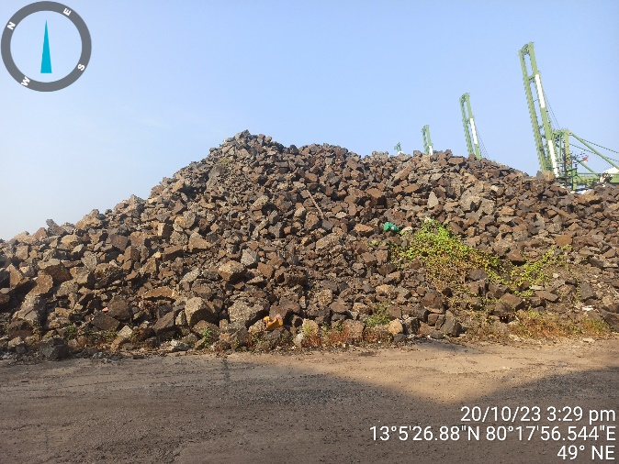
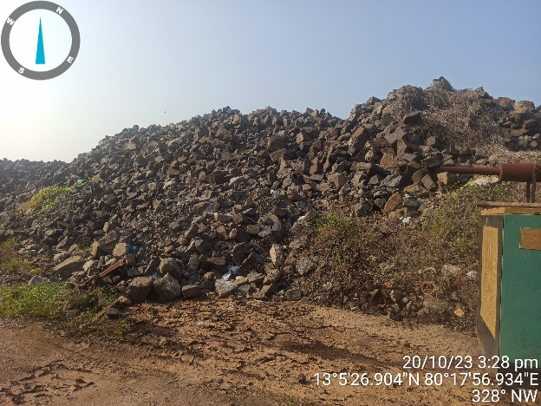
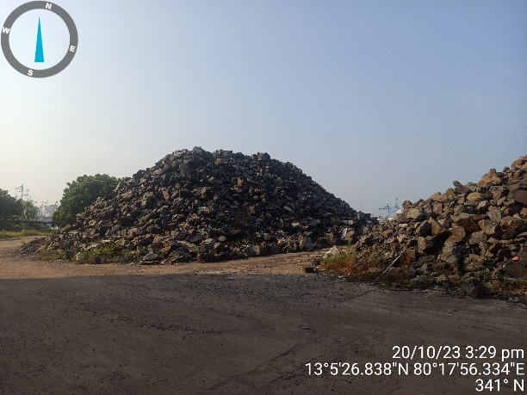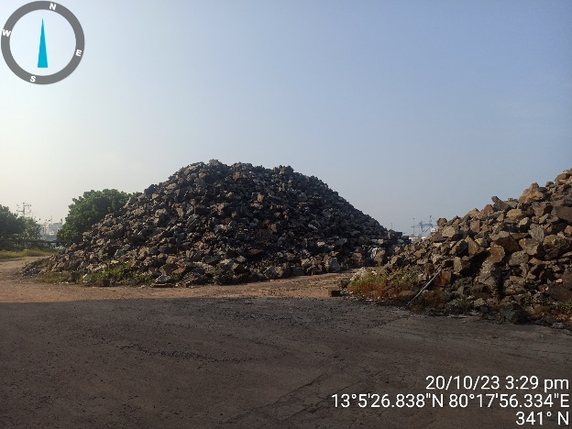

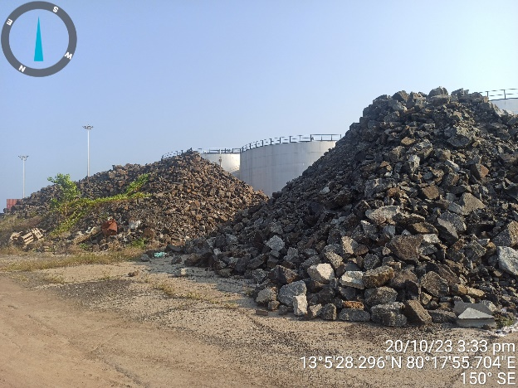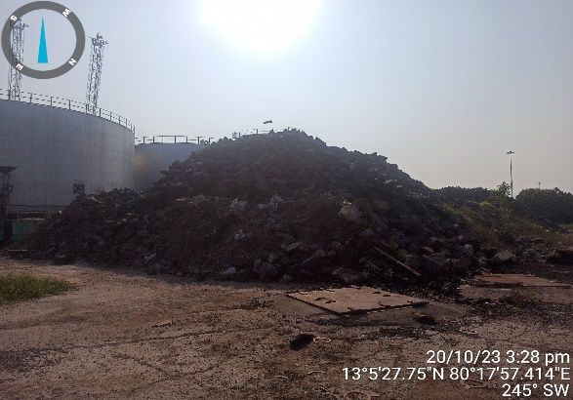
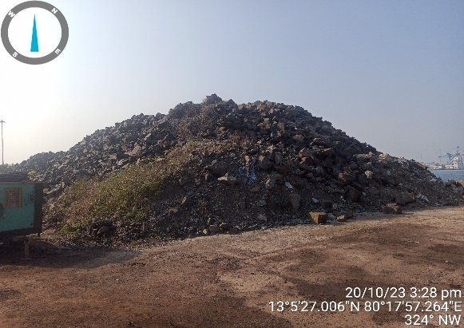

PHOTO IMAGE OF LOT NO. 04/2021,
SEMI COKE, IN BAGS ,
Country of origin : CHINA Importer : (Not Applicable)EXCESS LANDED
Weight : 80 Tons (approx.) To be sold on lot basis

