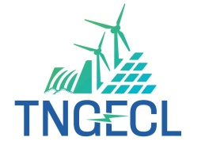
Tamil Nadu Green Energy Corporation Limited
NPKRR Maaligai,144, Anna Salai, Chennai - 600 002
Email: cences@tnebnet.org.
Notice Inviting Bid
Competitive Biddingis invited by TNGECL for selection of developer for setting up 15 MW Grid-Connected Solar PV Power Project with 15MW/45 MWh Battery Energy Storage System (BESS) in KarurDistrict on a Build-Own-Operate (BOO) basis, for a PPA period of 25 years vide CE/NCES/O.T.No.09/2025-26. Details of the tender areavailable at https://tntenders.gov.in/nicgep/app for submission of bids.

CE/ NCES/TNGECL

Tamil Nadu Green Energy Corporation Limited
NPKRR Maaligai,144, Anna Salai, Chennai - 600 002
Email: cences@tnebnet.org.
Notice Inviting Bid
Competitive Biddingis invited by TNGECL for selection of developer for setting up 15 MW Grid-Connected Solar PV Power Project with 15MW/45 MWh Battery Energy Storage System (BESS) in ThiruvarurDistrict on a Build-Own-Operate (BOO) basis, for a PPA period of 25 years vide CE/NCES/O.T.No.10/2025-26. Details of the tender areavailable at https://tntenders.gov.in/nicgep/app for submission of bids.

CE/ NCES/TNGECL

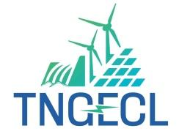
Tamil Nadu Green Energy Corporation Limited
NPKRR Maaligai,144, Anna Salai, Chennai - 600 002
Email: cences@tnebnet.org.
Notice Inviting Bid
Competitive Bidding is invited by TNGECL from prospective bidders for E-Tender for repowering of the old Wind Power Plant (18.75 MW) owned by TNGECL and development of a Solar Power Plant (16 MW) as a combined Wind-Solar Power Project with the proposal to sell power to TNPDCL under Tariff Based Competitive Bidding process with BOO model vide CE/NCES/O.T.No.07/2025-26. Details of the tender are available at https://tntenders.gov.in/nicgep/app for submission of bids.

CE/ NCES/TNGECL

Tamil Nadu Green Energy Corporation Limited
NPKRR Maaligai,144, Anna Salai, Chennai - 600 002
Email: cences@tnebnet.org.
Notice Inviting Bid
International Competitive Biddingis invited by TNGECL for selection of the developer through Tariff Based Competitive Bidding(TBCB) with e-reverse auction for procurement of 1500 MWh (375MW X 4 Hr) with 1.5 full charge–discharge cycles per day Standalone BESS to be established by BESS developers in seven Sub-stations of TANTRANSCO under the State Component of the VGF scheme of MoP supported by PSDF, on a capacity charge basis (Rupees per MW per month) under BOO model for a period of 15 years vide CE/NCES/O.T.No.08/2025-26. Details of the tender areavailable at https://tntenders.gov.in/nicgep/app for submission of bids.

CE/ NCES/TNGECL

