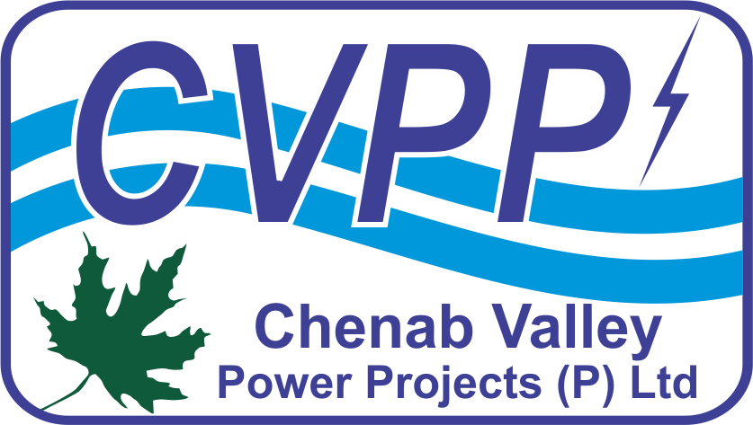
CHENAB VALLEY POWER PROJECTS [P] LIMITED
A Joint Venture of NHPC Limited (A Govt. of India Enterprise) & JKSPDC (A Govt. of J&K Enterprise)
Chenab Jal Shakti Bhawan, Opposite Saraswati Dham, Rail Head Complex, Jammu -180012 (J&K), India. CIN: U40105JK2011PTC003321; website: www.cvppindia.com

NOTICE INVITING TENDER (PRESS NOTICE)
E- Tender ID No.: CVPPPL/22-23/ET/1

NIT No.: CVPP/KWAR/E&M-PKG/2022 Date: 07.12.2022

Online bids are invited for and on behalf of Chenab Valley Power Projects [P] Ltd., on International Competitive Bidding (ICB) basis for “ELECTRO-MECHANICAL (E&M) WORKS PACKAGE (LOT-III) of KWAR HE PROJECT 540 MW, KISHTWAR DISTRICT OF UNION TERRITORY OF J&K, INDIA”. Bidders shall register themselves on the MSTC website to download and submit their bids. Detailed NIT can be viewed at www.cvppindia.com, https://eprocure.gov.in/epublish/app & https://www.mstcecommerce.com/eprochome/cvpppl/. Deadline for submission of online bid is 25.01.2023 (1500 Hrs).

General Manager (Contracts & Procurement)
Email: cont.proc@cvppindia.com

