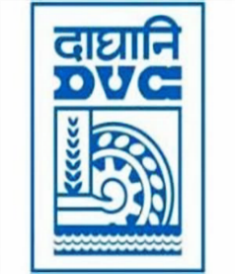
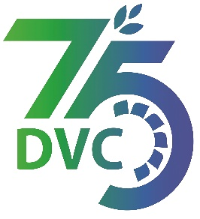
damaooadr GaaTI inagama
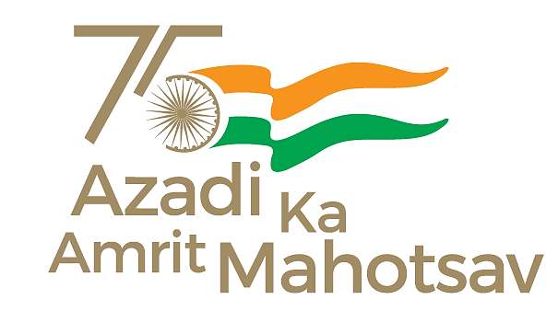
Damodar Valley Corporation
संविदाऔरसामग्रीविभाग
Contracts and Materials Department
डीवीसीटावर्स;तृतीयतल;वीआइपीरोड;कोलकाता-७०००५४टेलीफ़ैक्सन०-०३३-२३५५-२९३६
DVC Towers; 3rd Floor; VIP Road, Kolkata – 700054 Tele fax No.-033 – 2355 –2936.

E-Tender Notice

Damodar Valley Corporation invites Expression of Interest (EoI) from the eligible bidders for:
REFERENCE NO. | Description of item | Tender Downloading Period and Time
DVC NIT NO:- DVC/Tender/Head Quarter/OS & U /CMM/Supply/00038 dated 04/08/2022. ***************************  CPPTender ID:- 2022_DVC_124810_1 | Expression of Interest (EOI)for Selection of vendors for supply of Conveyor Belts at different power stations of DVC | From 11:00 Hrs. of 05/08/2022  up to 11:00 Hrs. of 03/09/2022

For further details and to participate in tender, please log on:
https://etenders.gov.in/eprocure/app

Note: For any Technical Queries call:-0120-4200 462, 0120-4001 002, 0120-4001 005,
0120-6277 787.

E-Mail Support:Technical - support-eproc(at)nic(dot)in

