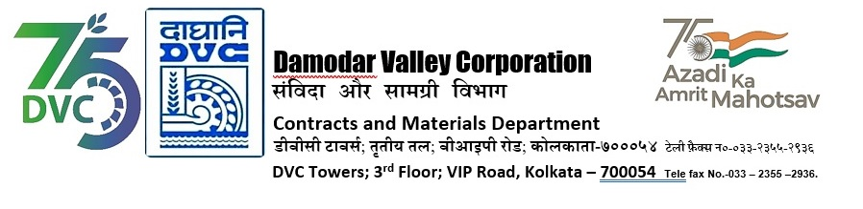
DAMODAR VALLEY CORPORATION
Contracts and Materials Department
DVC Towers; 3rd Floor; VIP Road, Kolkata – 700054
Tele fax No.-033 – 2355 –2936.

E-TENDER NOTICE

“THROUGH GeM PORTAL ONLY”

Sl. No. | NIT No. & Description of Work | Tender Downloading Time & Period
1. | GeMBid No. :  GEM/2024/B/5183983 Dated: 19-07-2024  Tender Description :  lifting of 5.0 (Five) LMT coal from NLC India Limited (NLCIL)- Talabira II & III OCP, Sambalpur, Odisha to DSTPS and other TPS of DVC in RCR mode. | From 20/07/2024 at 17:00 Hrs. (IST) to 05-08-2024 12:00 Hrs. (IST)
For further details and participate in the tender, please log https://gem.gov.in/
or www.dvc.gov.in [For view only]
for any help regarding the above tender contact to
GeM Customer care at https://gem.gov.in/contactUs

