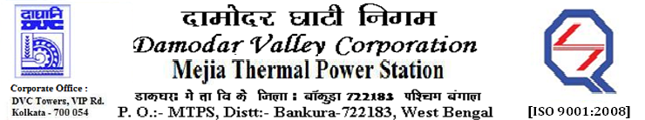
Phone No.: 03241- 263038 FAX: 03241-262287

E-Tender Notices

Damodar Valley Corporation invites online bids with On-line reverse auction (RA) from eligible bidders for:

 | NIT No. | Description of Job (s) | Tender Downloading Period & Time
1. | MT/O&M/QSF-05-07-05/22-23/MB-101/145 dtd. 16/11/2022 | BIENNIAL RATE CONTRACT for Mechanical Maintenance of Turbine Associated Equipment & Auxiliaries of 2X500 MW units#7&8, MTPS.
  From 14.00 Hrs. of 17.11.2022 to 11.30 Hrs. of 13.12.2022

For further details and to participate in the tender, please log on to DVC Website www.dvc.gov.in, and https://etenders.gov.in/eprocure/app
Note: e-procurement Helpdesk No. 9831683690 / Mob: 8240124812 may please be contacted.

Your faith fully,

Sd/-

Smt Archana Lakra,
SE (Tech), MTPS, DVC,
[archana.lakra@dvc.gov.in],
Mob: 9432861534

