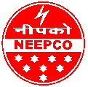  ISO: 9001, 14001,  & 45001 | xÉÉìlÉÇ <Çº]õxÉÇ <±ÉäÎC]ÅõEò {ÉÉ´É®ú EòÉì®ú{ÉÉä®äú¶ÉxÉ Ê±ÉÊ¨É]äõb÷  (¦ÉÉ®úiÉ ºÉ®úEòÉ®ú EòÉ =t¨É)  NORTH EASTERN ELECTRIC POWER CORPORATION LIMITED  (Government of India Enterprise)  Office of the Executive Director, Contracts & Procurement  Brookland Compound, Lower New Colony  Shillong-793 003, Meghalaya, India  Tel. No.0364-2227784 :: E-mail: contract@neepco.co.in  Website: www.neepco.co.in, CIN-U40101ML1976GOI001658 | 
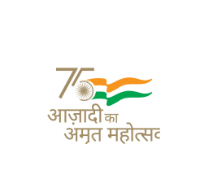
SHORT NOTICE INVITING BIDS (E-Tender)
(DOMESTIC COMPETITIVE BIDDING)
NIB No. 438 Dated 18-01-2024

NEEPCO Ltd. invites online electronic bids in the e-tender portal https://etenders.gov.in (Tender ID: 2024_NEEPC_182230_1) from prospective bidders fulfilling the Qualifying Requirement under Single-Stage Two-Envelope bidding system through Domestic Competitive Bidding (DCB) route for carrying out the work of “Drilling works for Kurung H. E. Project, Arunachal Pradesh”.
For further details, the interest bidders may visit websites https://etenders.gov.in and www.neepco.co.in. Subsequent Corrigendum/ Addendum/ Clarifications to the tender shall be published only on the websites mentioned above. Last date for submission of bids is 15-02-2024 by 14:00 Hours.

Place: Shillong  Dated: 18-01-2024 | Sd/-  Executive Director  Contracts & Procurement

