

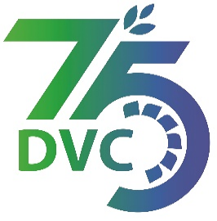

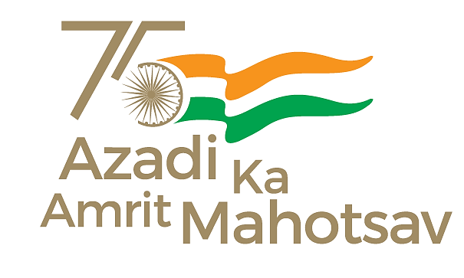

Damodar Valley Corporation

संविदा और सामग्री विभाग

**Contracts and Materials Department**

डीवीसी टावर्स; तृतीय तल; वीआइपी रोड; कोलकाता-७०००५४ टेली फ़ैक्स न०-०३३-२३५५-२९३६

**DVC Towers; 3rd Floor; VIP Road, Kolkata – 700054 Tele fax No.-033 – 2355 –2936.**

|  |  |  |
| --- | --- | --- |
| **DAMODAR VALLEY CORPORATION**  **Contracts and Materials Department**  **DVC Towers; 3rd Floor; VIP Road, Kolkata – 700054**  **Tele fax No.-033 – 2355 –2936.** | | |
| **NO. DVC/Tender/Head Quarter/FUEL 1/CMM/Works and Service/00015 dated 03/05/2023** | | |
| **E-TENDER NOTICE**  **“THROUGH GeM portal ONLY”**   |  |  |  | | --- | --- | --- | | **Sl. No.** | **NIT No. & Description of Work** | **Tender Downloading Time & Period** | | 1. | **NIT/Bid No. :** GEM/2023/B/3391427Dated 03/05/2023  **Description :** Annual Contract for loading & transportation of coal by road with dumper/ tipper from different collieries of CCL/ Bermo Mines to BTPS Coal Yard in the distance slab of (08-20 km and 21-30 km)”.  . | From 16:00 hrs of 03/05/2023 to 12:00 hrs of 31/05/2023 | | For further details and participate in the tender, please log https://gem.gov.in/  or www.dvc.gov.in [For view only]  for any help regarding the above tender contact to  GeM Customer care at <https://gem.gov.in/contactUs>  Mr. Nawajesh Rahman (Mob. No. 03366072327, 9831683690) | | | | | |
|  |