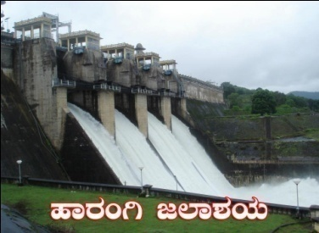 | Cauvery Neeravari Nigama Niyamitha  (Government of Karnataka Undertaking)  Office of the Executive Engineer,  No.2, Harangi Right Bank Canal Division, Hunsur,  MysoreDistrict-571105  ( 08222-252211 Fax: 252211 *eeharangi@yahoo.co.in | 

CORRIGENDUM-1 Dated: 05-02-2024
SHORT TERM TENDER NOTIFICATION NO:03/2023-24, Dated:25-01-2024.
(Through Karnataka Public Procurement Portal Only)

Refer to our office Short term Tender Notification No.03/2023-24 Dated 25-01-2024 The amount put to tender Rs. 8359.80 lakhs, EMD Rs. 83.60 Lakhs. The contractors can have access/download e-procurement tender document from 06-02-2024 onwards The last date to submit the filled tender document is 13-02-2024 (4.00 PM). Technical bid will be opened on 14-02-2024 at 4.30 PM onwards and Financial bid will be opened on 16-02-2024 at 11.00 AM onwards or on any other convinient date and time. Other details will reamins same. Additional information can be obtained from e-procurement platform https://kppp.karnataka.gov.in/kppp or from the undersigned during office hours.

Executive Engineer,
Cauvery Neeravari Nigama Niyamitha,
No.2 Harangi Right Bank Canal Division,
Hunsur, Mysore District - 571105

