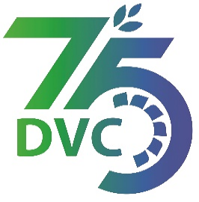 **damaooadr GaaTI inagama**



Damodar Valley Corporation

संविदा और सामग्री विभाग

**Contracts and Materials Department**

डीवीसी टावर्स; तृतीय तल; वीआइपी रोड; कोलकाता-७०००५४ टेली फ़ैक्स न०-०३३-२३५५-२९३६

**DVC Towers; 3rd Floor; VIP Road, Kolkata – 700054 Tele fax No.-033 – 2355 –2936.**

|  |  |  |
| --- | --- | --- |
| **DAMODAR VALLEY CORPORATION**  **Contracts and Materials Department**  **DVC Towers; 3rd Floor; VIP Road, Kolkata – 700054**  **Tele fax No.-033 – 2355 –2936.** | | |
| **NO.** [DVC/Tender/Head Quarter/PROJ-TUBED-COAL MINING/CMM/Works and Service/00006/Capital](https://eba.dvc.gov.in/EBA2/faces/Landing_CMM.jsf)  Date: 06/03/2023 | | |
| **E-TENDER NOTICE**   |  |  |  | | --- | --- | --- | | **Sl. No.** | **NIT No. & Description of Work** | **Tender Downloading Time & Period** | | 1. | **NIT No. :** [**DVC/Tender/Head Quarter/PROJ-TUBED-COAL MINING/CMM/Works and Service/00006/Capital**](https://eba.dvc.gov.in/EBA2/faces/Landing_CMM.jsf) **Date: 06/03/2023**  **Description :** EOI for Hiring/engagement of Independent Engineer for a period of three (03) years for Tubed Coal Mines, Latehar, Jharkhand | From 15:00 hrs of 06/03/2023 to 12:00 hrs of 03/04/2023 | | For further details and participate in the tender, please log <https://etenders.gov.in/eprocure/app>  or www.dvc.gov.in [For view only]  for any help regarding the above tender contact to  Mr. Nawajesh Rahman (Mob. No. 03366072327, 9831683690) | | | | | |
|  |

(Naresh Prasad Mandal)

DCE(C&M)

—rs ,oa nk?kkfu ds fy,@For & on behalf ofDVC