COUNTRY PROFILE REPORT
ITJ DIVISION, DGCI&S
INDIA - GERMANY BILATERAL TRADE RELATIONS
INTRODUCTION & BRIEF ECONOMIC OVERVIEW

1. The Federal Republic of Germany is located in the heart of Europe. Following German reunification in October 1990, the former Federal Republic of Germany and the German Democratic Republic became a single federal state. Germany borders Denmark to the north; Poland and the Czech Republic to the east; Austria and Switzerland to the south; and France, Luxembourg, Belgium and the Netherlands to the west. It is a member of major international and regional institutions, including the United Nations, the European Union, NATO, the Council of Europe and the OECD.

2. Germany has a highly developed social market economy and is Europe’s largest economy. As shown in Table 1, real GDP growth was -0.2 per cent in 2023 and was projected at 0.2 per cent in 2024 and 1.3 per cent in 2025. Headline inflation was projected to moderate from 6.0 per cent in 2023 to 2.5 per cent in 2024 and 2.2 per cent in 2025, while the unemployment rate remained low, at around 3 per cent. Table 1 also indicates a persistent current-account surplus of 6.3 per cent of GDP and a merchandise trade surplus of more than 4 per cent of GDP, alongside public debt projected to decline to 62.4 per cent of GDP in 2025.

TABLE-1
Germany: Selected Economic Indicators, 2023-25
Selected Economic Indicators |  | Projections | Projections
 | 2023 | 2024 | 2025
Output
Real GDP growth (%) | -0.2 | 0.2 | 1.3
Total domestic demand growth (%) | -1.1 | 0.2 | 1.2
Output gap (% of potential GDP) | -0.3 | -1.0 | -0.7
Employment
Unemployment rate (%, ILO) | 3.0 | 3.3 | 3.1
Employment growth (%) | 1.1 | 0.0 | 0.2
Prices
Inflation (%, headline, period avg.) | 6.0 | 2.5 | 2.2
Inflation (%, core, period avg.) | 6.3 | 3.0 | 2.3
General Government Finances
Fiscal balance (% of GDP) | -2.4 | -1.7 | -1.3
Revenue (% of GDP) | 46.2 | 46.3 | 46.8
Expenditure (% of GDP) | 48.6 | 48.0 | 48.1
Cyclically adjusted balance (% of GDP) | -2.3 | -1.2 | -0.9
Public debt (% of GDP) | 63.6 | 63.8 | 62.4
Money and Credit
Broad money (M3) (end of year, % change) 2 | 0.4 | … | …
Credit to private sector (% change) | 1.1 | … | …
10-year government bond yield (%) | 2.6 | … | …
Balance of Payments
Current account balance (% of GDP) | 6.3 | 6.3 | 6.3
Trade balance (% of GDP) | 4.3 | 4.4 | 4.2
Exports of goods (% of GDP) | 38.0 | 36.9 | 36.3
Volume (% change) | -1.1 | 2.4 | 3.2
Imports of goods (% of GDP) | 32.1 | 31.0 | 30.8
Volume (% change) | -5.0 | 1.2 | 3.1
Service trade balance (% of GDP) | -1.5 | -1.5 | -1.3
FDI balance (% of GDP) | 1.4 | 2.2 | 2.2
Reserves minus gold (billions of USD) | 100.4 | … | …
External Debt (% of GDP) | 148.1 | … | …
Exchange Rate
REER (% change) | 3.3 | … | …
NEER (% change) | 3.4 | … | …
Real effective rate (2010=100) 3 | 96.7 | … | …
Nominal effective rate (2010=100) 4 | 105.9 | … | …
Sources: Deutsche Bundesbank, Eurostat, Federal Statistical Office, Haver Analytics, and IMF staff calculations.
1/ GDP and its components are unadjusted for working days.
2/ Reflects Germany's contribution to M3 of the euro area.
3/ Real effective exchange rate, CPI based, all countries.
4/ Nominal effective exchange rate, all countries.

FOREIGN TRADE

3. According to the latest detailed WITS/UN Comtrade data available for 2023, Germany’s main export destinations were the United States, France, the Netherlands, China and Poland, while its leading sources of imports were China, the Netherlands, the United States, Poland and Italy. The principal HS-6 export items included motor vehicles, medicaments, biological products and aircraft; major imports included crude and refined petroleum, biological products, motor vehicles and telecommunications apparatus. WITS records total exports of USD 1,725,527 million and total imports of USD 1,486,747 million in 2023.

4. Germany’s merchandise exports increased from USD 1,385,852 million in 2020 to USD 1,691,415 million in 2024. Exports rose sharply by 18.02 per cent in 2021 and continued to increase in 2022 and 2023, before declining by 1.98 per cent in 2024. Over 2020–2024, exports recorded a compound annual growth rate (CAGR) of 5.11 per cent.

5. Merchandise imports rose from USD 1,173,167 million in 2020 to USD 1,433,340 million in 2024. Imports increased by 21.44 per cent in 2021 and 12.20 per cent in 2022, before contracting by 6.99 per cent in 2023 and 3.59 per cent in 2024. The CAGR of imports over this period was 5.14 per cent.

6. Germany maintained a merchandise trade surplus throughout 2020–2024. The surplus narrowed to USD 97,285 million in 2022, then widened to USD 238,780 million in 2023 and USD 258,075 million in 2024. Total merchandise trade reached USD 3,124,755 million in 2024, with a CAGR of 5.12 per cent over 2020–2024.

TABLE - 2
GERMANY'S TOTAL EXPORTS AND IMPORTS, VOLUME OF TRADE
AND BALANCE OF TRADE, 2020-2024
(Figures in USD Million)
Year | Exports | Percentage Growth in Exports | Imports | Percentage Growth in Imports | Volume of Trade | Percentage Growth in Vol. of Trade | Balance of Trade
2020 | 1385852 |  | 1173167 |  | 25,59,019 |  | 212685
2021 | 1635600 | 18.02 | 1424675 | 21.44 | 30,60,275 | 19.59 | 210925
2022 | 1695807 | 3.68 | 1598522 | 12.20 | 32,94,329 | 7.65 | 97285
2023 | 1725527 | 1.75 | 1486747 | -6.99 | 32,12,274 | -2.49 | 238780
2024 | 1691415 | -1.98 | 1433340 | -3.59 | 31,24,755 | -2.72 | 258075
CAGR |  | 5.11 |  | 5.14 |  | 5.12
NOTE: Figures relate to the calendar year (January-December).
SOURCE: UN Comtrade.

FIGURE-1
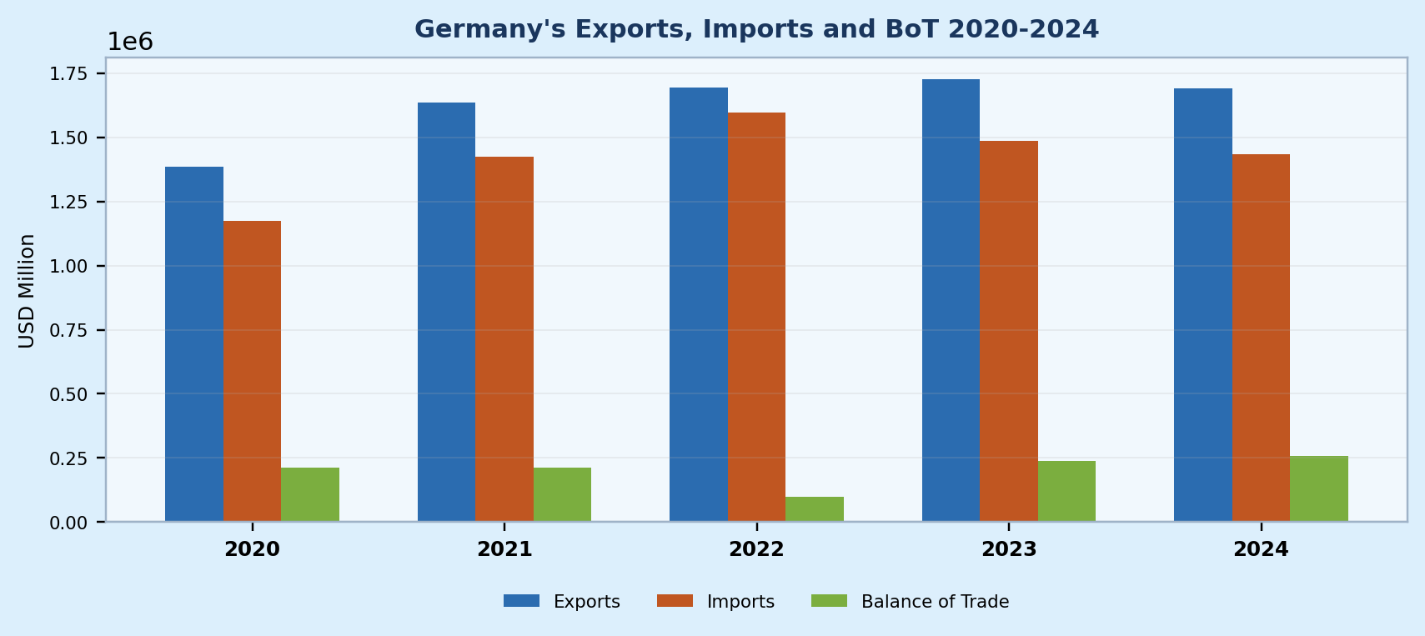
BILATERAL TRADE WITH INDIA

Merchandise Trade

7. Germany is one of India’s major trading partners in Europe. In FY 2024–25, India’s exports to Germany represented 2.41 per cent of its total exports, while imports from Germany accounted for 2.63 per cent of its total imports. Germany ranked as India’s ninth-largest export destination, and bilateral merchandise trade accounted for about 2.17 per cent of India’s total international trade, according to the DGCI&S database.

8. The total value of India–Germany merchandise trade increased from USD 21,769.30 million in FY 2020–21 to USD 29,392.13 million in FY 2024–25. Over this period, bilateral trade recorded a CAGR of 7.79 per cent, despite a contraction in FY 2023–24.

9. India recorded a merchandise trade deficit with Germany in every year from FY 2020–21 to FY 2024–25. Indian exports increased from USD 8,126.28 million to USD 10,536.17 million, representing a CAGR of 6.71 per cent, while imports rose from USD 13,643.02 million to USD 18,855.96 million, representing a CAGR of 8.43 per cent. Consequently, the trade deficit widened from USD 5,516.74 million in FY 2020–21 to USD 8,319.79 million in FY 2024–25.
TABLE-3
INDIA'S MERCHANDISE EXPORTS AND IMPORTS WITH RESPECT TO GERMANY,
FY 2020-21 TO 2024-25
(Value in USD Million)
Year | Exports from India to Germany | Percentage Growth in Exports | Imports from Germany to India | Percentage Growth in Imports | Volume of Trade | Percentage Growth in Vol. of Trade | Balance of Trade
2020-21 | 8126.28 |  | 13643.02 |  | 21769.30 |  | -5516.74
2021-22 | 9884.70 | 21.64 | 14968.10 | 9.71 | 24852.80 | 14.16 | -5083.40
2022-23 | 10136.69 | 2.55 | 16601.53 | 10.91 | 26738.22 | 7.59 | -6464.84
2023-24 | 9841.55 | -2.91 | 16270.35 | -1.99 | 26111.90 | -2.34 | -6428.80
2024-25 | 10536.17 | 7.06 | 18855.96 | 15.89 | 29392.13 | 12.56 | -8319.79
CAGR |  | 6.71 |  | 8.43 |  | 7.79
NOTE: Figures relate to the financial year (April-March).
SOURCE: DGCI&S, Ministry of Commerce & Industry.

FIGURE-2
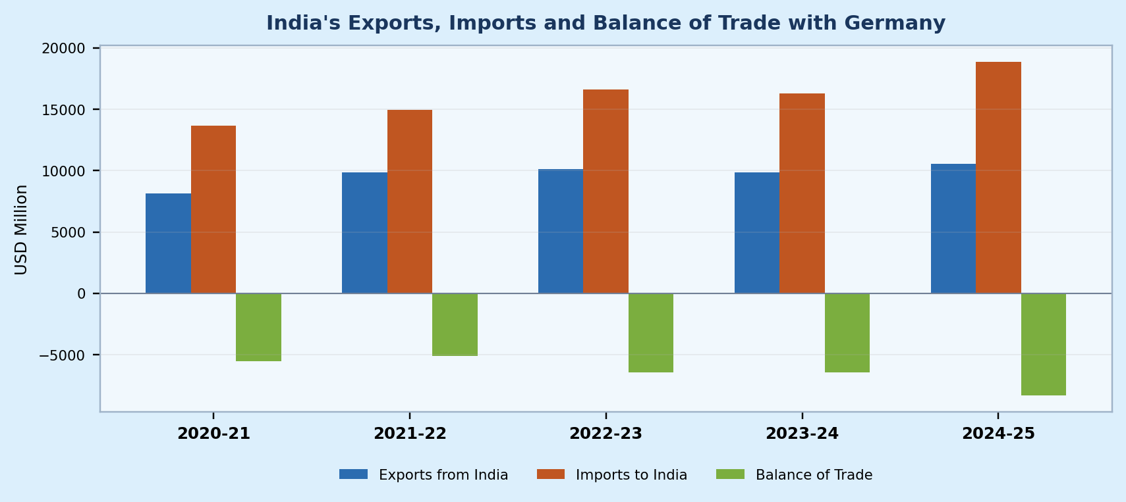

10. An examination of the commodity composition of bilateral trade, as presented in Tables 4 and 5, yields the following observations:

(a) Table 4 shows that Electric Machinery and Equipment was India’s largest listed export item to Germany in FY 2024–25, valued at USD 950.51 million and representing 9.02 per cent of India’s exports to Germany. Telecom Instruments ranked second, at USD 537.75 million (5.10 per cent), followed by RMG Cotton including Accessories, at USD 515.31 million (4.89 per cent). Electric Machinery and Equipment recorded year-on-year growth of 28.97 per cent in FY 2024–25, while Telecom Instruments grew by 43.53 per cent.

(b) Table 5 shows that Aircraft, Spacecraft and Parts was the largest listed import item from Germany in FY 2024–25, accounting for 15.83 per cent of total imports from Germany, at USD 2,984.63 million. Medical and Scientific Instruments and Electric Machinery and Equipment were also major items, valued at USD 1,078.12 million and USD 1,007.75 million, respectively. Total imports from Germany reached USD 18,855.96 million in FY 2024–25, an increase of 15.89 per cent over the previous year.

TABLE - 4
INDIA'S MAJOR ITEMS OF MERCHANDISE EXPORTS TO GERMANY
FY 2020-21 TO 2024-25 AND THEIR GROWTH RATES
(Value in USD Million)
Sl.  No. | Name of the Merchandise  Commodities | Value of Exports |  |  |  |  | Annual Growth Rates
 |  | 2020-21 | 2021-22 | 2022-23 | 2023-24 | 2024-25 | 21-22 over  2020-21 | 22-23 over  2021-22 | 23-24 over  2022-23 | 24-25 over  2023-24
1 | Electric Machinery and Equipments | 634.03 | 663.06 | 717.30 | 737.00 | 950.51 | 4.58 | 8.18 | 2.75 | 28.97
 | Share in total export | 7.65 | 8.16 | 7.26 | 7.27 | 9.02
2 | Telecom Instruments | 397.07 | 316.47 | 476.51 | 374.66 | 537.75 | -20.30 | 50.57 | -21.37 | 43.53
 | Share in total export | 4.79 | 3.89 | 4.82 | 3.70 | 5.10
3 | RMG Cotton Including Accessories | 461.82 | 570.52 | 574.81 | 441.05 | 515.31 | 23.54 | 0.75 | -23.27 | 16.84
 | Share in total export | 5.57 | 7.02 | 5.82 | 4.35 | 4.89
4 | Products of Iron and Steel | 316.78 | 458.72 | 471.32 | 445.14 | 466.62 | 44.81 | 2.75 | -5.55 | 4.83
 | Share in total export | 3.82 | 5.64 | 4.77 | 4.39 | 4.43
5 | Auto Components/ Parts | 277.67 | 356.80 | 358.34 | 420.71 | 439.59 | 28.50 | 0.43 | 17.41 | 4.49
 | Share in total export | 3.35 | 4.39 | 3.63 | 4.15 | 4.17
6 | Indl. Machinery For Dairy ETC. | 274.72 | 417.61 | 476.09 | 531.02 | 413.99 | 52.01 | 14.00 | 11.54 | -22.04
 | Share in total export | 3.31 | 5.14 | 4.82 | 5.24 | 3.93
7 | Drugs Formulations Biologicals | 306.41 | 287.36 | 271.75 | 321.13 | 365.73 | -6.22 | -5.43 | 18.17 | 13.89
 | Share in total export | 3.70 | 3.54 | 2.75 | 3.17 | 3.47
8 | Other Misc. Engineering Items | 179.12 | 232.49 | 238.80 | 278.24 | 320.34 | 29.80 | 2.71 | 16.52 | 15.13
 | Share in total export | 2.16 | 2.86 | 2.42 | 2.74 | 3.04
9 | Residual Chemical and Allied Products | 305.49 | 314.74 | 343.05 | 356.68 | 300.21 | 3.03 | 8.99 | 3.97 | -15.83
 | Share in total export | 3.68 | 3.87 | 3.47 | 3.52 | 2.85
10 | Footwear of Leather | 205.41 | 218.51 | 238.45 | 218.38 | 229.16 | 6.38 | 9.13 | -8.42 | 4.94
 | Share in total export | 2.48 | 2.69 | 2.41 | 2.15 | 2.17
 | Total exports to GERMANY | 8126.28 | 9884.70 | 10136.69 | 9841.55 | 10536.17 | -1.99 | 21.64 | 2.55 | 3.94
NOTE: Figures relate to each financial year (April-March).
SOURCE: DGCI&S, Ministry of Commerce & Industry.

TABLE - 5
INDIA'S MAJOR ITEMS OF MERCHANDISE IMPORTS FROM GERMANY
FY 2020-21 TO 2024-25 AND THEIR GROWTH RATES
(Value in USD Million)
Sl.  No. | Name of the Merchandise  Commodities | Value of Imports |  |  |  |  | Annual Growth Rates
 |  | 2020-21 | 2021-22 | 2022-23 | 2023-24 | 2024-25 | 21-22 over  2020-21 | 22-23 over  2021-22 | 23-24 over  2022-23 | 24-25 over  2023-24
1 | Aircraft, Spacecraft and Parts | 3588.27 | 1778.82 | 2403.13 | 1433.58 | 2984.63 | -50.43 | 35.10 | -40.35 | 108.19
 | Share in total import | 26.30 | 11.88 | 14.48 | 8.81 | 15.83
2 | Indl. Machinery For Dairy Etc. | 1269.17 | 1884.15 | 1961.32 | 2109.64 | 336.07 | 48.46 | 4.10 | 7.56 | -84.07
 | Share in total import | 9.30 | 12.59 | 11.81 | 12.97 | 1.78
3 | Medical and Scientific Instruments | 571.87 | 765.70 | 871.57 | 1023.74 | 1078.12 | 33.89 | 13.83 | 17.46 | 5.31
 | Share in total import | 4.19 | 5.12 | 5.25 | 6.29 | 5.72
4 | Electric Machinery and Equipments | 712.37 | 889.87 | 855.59 | 1043.92 | 1007.75 | 24.92 | -3.85 | 22.01 | -3.46
 | Share in total import | 5.22 | 5.95 | 5.15 | 6.42 | 5.34
5 | Auto Components/Parts | 375.70 | 661.82 | 809.23 | 885.16 | 954.60 | 76.16 | 22.27 | 9.38 | 7.84
 | Share in total import | 2.75 | 4.42 | 4.87 | 5.44 | 5.06
6 | Electronic Instruments | 533.84 | 676.37 | 763.98 | 916.30 | 883.15 | 26.70 | 12.95 | 19.94 | -3.62
 | Share in total import | 3.91 | 4.52 | 4.60 | 5.63 | 4.68
7 | Electronic Components | 462.48 | 552.84 | 687.78 | 816.54 | 715.63 | 19.54 | 24.41 | 18.72 | -12.36
 | Share in total import | 3.39 | 3.69 | 4.14 | 5.02 | 3.80
8 | Other Misc. Engineering Items | 346.44 | 442.26 | 622.51 | 681.52 | 686.66 | 27.66 | 40.76 | 9.48 | 0.75
 | Share in total import | 2.54 | 2.95 | 3.75 | 4.19 | 3.64
9 | Residual Chemicals and Allied Products | 472.19 | 619.64 | 500.74 | 503.86 | 473.28 | 31.23 | -19.19 | 0.62 | -6.07
 | Share in total import | 3.46 | 4.14 | 3.02 | 3.10 | 2.51
10 | Machine Tools | 225.61 | 249.95 | 315.66 | 342.34 | 400.69 | 10.79 | 26.29 | 8.45 | 17.04
 | Share in total import | 1.65 | 1.67 | 1.90 | 2.10 | 2.13
 | Total import from GERMANY | 13643.02 | 14968.10 | 16601.53 | 16270.35 | 18855.96 | 9.71 | 10.91 | -1.99 | 15.89
NOTE: Figures relate to each financial year (April-March).
SOURCE: DGCI&S, Ministry of Commerce & Industry.
NOTICE
Rights of permission for reproduction in part or entirely of these official papers published in the Indian Trade Journal are reserved by the Directorate General of Commercial Intelligence & Statistics, Kolkata - 700 107.

