नोटिंग शीट
केवल नागपुर कोर्ट के अधिकार क्षेत्र मे Under Jurisdiction of Nagpur Court only
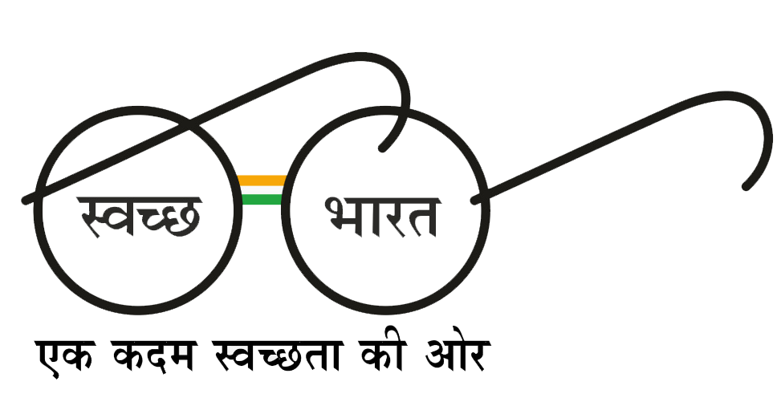

वेस्टर्न कोलफील्ड्स लिमिटेड
Western Coalfields Limited
(मिनीरत्न कंपनी) (A Miniratna Company)
(कोल इंडिया लि॰ की अनुषंगी कंपनी)
(A Subsidiary of Coal India Limited)
सामग्री प्रबन्धन विभाग Department of Material Management
email: gmmm-purchase.wcl@coalindia.in FAX: 0712-2510284
CIN – U10100MH1975GO1018626 www.westerncoal.in

नोट शीट क्रमांक/Note Sheet No. :
अधिकारी का नाम/Name of Officer :

GLOBAL E-TENDER WITH REVERSE AUCTION

Tender no. | Tender ID | Item Description | Tender  Value | Bid Submission End Date | Bid Opening Date
WCL-Hq-Pur-spk-ra-e018-2022-23 | 2022_WCL_260846_1 | Open Limited Global E-Tender with Reverse auction for Supply of Spares for spare parts of REL-650 Drill Spares (OPM CATEGORY ITEMS) | Rs. 88,30,251/- | 01-Dec-2022 11:00 AM | 02-Dec-2022 11:00 AM

The detailed Tender is available on e-Procurement portal https://coalindiatenders.nic.in/
and any corrigendum to this Tender shall also be available on this e-Procurement portal.

भवदीय
मुख्य प्रबंधक(सा.प्र), प्रशासन

