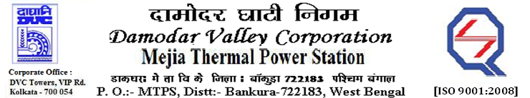

**Phone No.: 03241**- **263038FAX: 03241-262287**

**E-Tender Notices**

Damodar Valley Corporation invites online bids with **On-line reverse auction (RA)** from eligible bidders for:

|  |  |  |  |
| --- | --- | --- | --- |
|  | NIT No. | Description of Job (s) | Tender Downloading Period & Time |
| 1*.* | MT/O&M/QSF-05-06-08/22-23/MB90 (ReT)/135 dtd. 01/11/2022 | Rate Contract for C&I system (field portion) of main plant along with its auxiliaries including works related to the C&I works of AHP & ETP (excluding Chlorination Plant) of Unit # 4 (210MW), Unit # 5 (250MW) & Unit # 6 (250MW) of MTPS, DVC for Two (02) years, on OTE basis with e-reverse auction. | |  | | --- | | From 14.35 Hrs. of 02.11.2022 to 11.30 Hrs. of 28.11.2022 | |

For further details and to participate in the tender, please log on to DVC Website [www.dvc.gov.in](http://www.dvc.gov.in), and <https://etenders.gov.in/eprocure/app>

*Note*: e-procurement Helpdesk No. 9831683690 / Mob:8240124812 may please be contacted.

Your faith fully,

Sd/-

Ms.Archana Lakra,

SE (Tech), MTPS, DVC,

[archana.lakra@dvc.gov.in],

Mob: 9432861534

Date: 07.11.2022