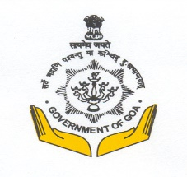

|  |  |
| --- | --- |
| **Department of Archaeology**  **Government of Goa**  **Ourem Road, Mala, Panaji, Goa, 403 001, India** | |
| **No. 8/252/2020/DAA-55** | **Date: 28/10/2022** |
| **(E-tendering)** | |
| Online tender Notice **No. 8/252/2020/DAA-55 Date: 31/10/2022 has been issued.** | |
| Name of the work: **RESTORATION OF CHAPORA FORT, ANJUNA BARDEZ GOA.** | |
| For eligibility and participation log on to <https://eprocure.goa.gov.in> | |
| **Sd/-** | |
| **(Dr. Nilesh B. Fal Dessai)**  **Director of Archaeology** | |