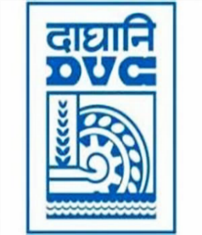

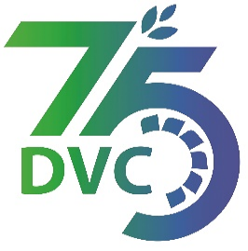

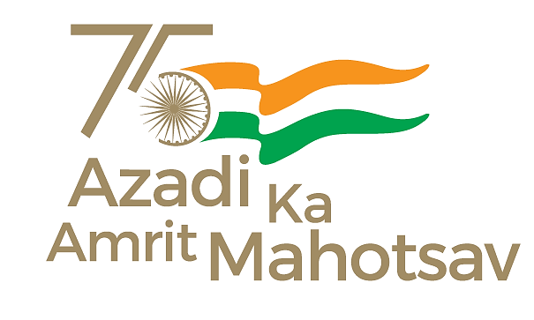

Damodar Valley Corporation

संविदा और सामग्री विभाग

**Contracts and Materials Department**

डीवीसी टावर्स; तृतीय तल; वीआइपी रोड; कोलकाता-७०००५४ टेली फ़ैक्स न०-०३३-२३५५-२९३६

**DVC Towers; 3rd Floor; VIP Road, Kolkata – 700054 Tele fax No.-033 – 2355 –2936.**

|  |  |  |
| --- | --- | --- |
| **DAMODAR VALLEY CORPORATION**  **Contracts and Materials Department**  **DVC Towers; 3rd Floor; VIP Road, Kolkata – 700054**  **Tele fax No.-033 – 2355 –2936.** | | |
| **NO.** GEM/2024/B/4566609 Dated: 16-02-2024 | | |
| **E-TENDER NOTICE**  **“THROUGH e-TENDERING PROCESS ONLY”**   |  |  |  | | --- | --- | --- | | **Sl. No.** | **NIT No. & Description of Work** | **Tender Downloading Time & Period** | | 1. | **NIT/Bid No. :** GEM/2024/B/4566609 Dated: 16-02-2024  **Description :** Procurement of Caustic Soda Flakes conforming to IS 252(Latest) for different Power Stations of DVC  . | upto 16:00 hrs of 15/03/2024 | | For further details and participate in the tender, please log GeM Portal or www.dvc.gov.in [For view only] | | | | | |
|  |