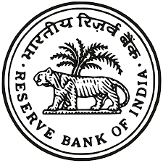
Reserve Bank of India
New Delhi
Notice Inviting Tender
E-Tenders under two bid system (Technical bid and Price bid) are invited from experienced and licensed contractors/operators/vendors for the following items of work:
- Contract for supply of sufficient number of adult and able-bodied labourers for handling of coin bags and note boxes. (E tender NoRBI/Delhi Regional Office/Issue/1/24-25/ET/923[Supply of labour-Coin and note])
- Contract for disposal of Shredded Currency note briquettes/ shreds. (E-tender NoRBI/Delhi Regional Office/Issue/2/24-25/ET/926[Disposal of shredded notes])
- Supply of transport for movement of currency note boxes / coin bags (E-tender NoRBI/Delhi Regional Office/Issue/3/24-25/ET/927[TRANSPORT OF NOTES COIN -DELHI])
- Providing vehicles to police escort for accompanying remittances(E-tender NoRBI/Delhi Regional Office/Issue/4/24-25/ET/928[PROVIDING TAXI SERVICES POLICE])
- The E-Tenders will be available for viewing and downloading from February 13, 2025, at 11:00 Hours. The last date of submission of e-tenders is March 20, 2025,upto 14.00 Hours. For full detailsof the tenders, please visit our website www.rbi.org.in or www.mstcecommerce.com/eprocn or contact us at Issue Department, Reserve Bank of India, 6, Sansad Marg, New Delhi -110001.
- The Bank reserves the right to reject any or all the tenders without assigning any reason thereof.
NOTE – Corrigendum, if any, issued forthe above E- tenders, will be published on the Bank’s and MSTC website.

Regional Director
New Delhi

