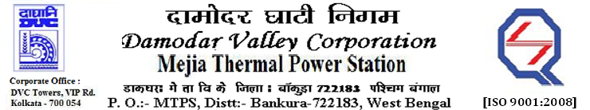

**Phone No.: 03241**- **263038FAX: 03241-262287**

**E-Tender Notice**

Damodar Valley Corporation invites online bids with On-line reverse auction (RA) from eligible bidders for:

|  |  |  |  |
| --- | --- | --- | --- |
|  | NIT No. | Description of Job (s) | Tender Downloading Period & Time |
| 1. | MT/O&M/QSF-05-06-14/22-23/DBN (338)/129 dtd. 07/10/2022 | Annual Rate Contract (ARC) for maintenance of various equipment of (a) Water Treatment Plants (U#1-6),(b) Barrage Intake Pump house(U#1-6), (c) DM Plants(U#1-6), (d) Miscellaneous equipment at reservoirpump house, (e) Leakages in different pipelines and replacement/modification of pipe lines of differentsizes including fire-fighting lines & accessories (U#1-6) and (f) Removal of sludge & mud from thesludge pit of water treatment plant of U#1-3, under OFMS-1, DVC, MTPS | From 18.55 Hrs. of 08.10.2022 to 11.00 Hrs. of 21.10.2022 |
| 2. | MT/O&M/QSF-05-06-10/22-23/VV(216)/130 dtd. 10/10/2022 | Annual Manning and Operation on round the clock basis for 05(five) nos. Panel Operated Cabins, 06(Six) nos. Level Crossing Gates (existing), 04(four) nos. of additional new Level Crossing Gates after complete construction, 01(one) no. Central Railway Control Room and round the clock manning for OHE isolator operation work in the Captive Railway Network of Mejia Thermal Power Station, DVC.”. | From 15.00 Hrs. of 10.10.2022 to 11.30 Hrs. of 31.10.2022 |
| 3. | MT/O&M/QSF-05-06-04/22-23/VV(213)/131 dtd. 14/10/2022 | Rate Contract for Loading, Transportation, and Unloading of Stones/boulders and other extraneous materials removed from running conveyors at CHP#1-6 & CHP#7-8, MTPS, DVC | From 18.55 Hrs. of 14.10.2022 to 11.00 Hrs. of 11.11.2022 |

For further details and to participate in the tender, please log on to DVC Website [www.dvc.gov.in](http://www.dvc.gov.in), and <https://etenders.gov.in/eprocure/app>.

Note: e-procurement Helpdesk No. 9831683690 / Mob:8240124812 may please be contacted.

Your faithfully,

-sd-

Shri P.K. Ghosh

SE (Tech), MTPS (O&M), DVC,

[pradip.ghosh@dvc.gov.in]