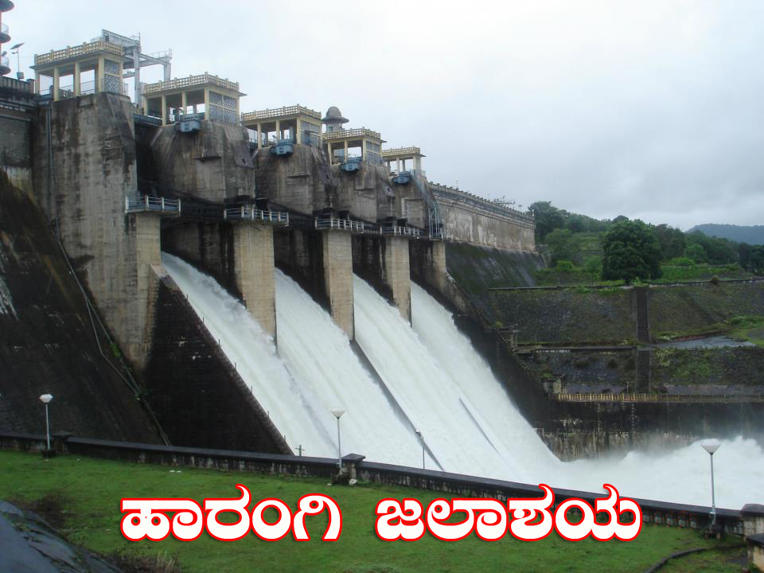 | Cauvery Neeravari Nigama Niyamita  (Govt. of Karnataka undertaking)  Office of the Executive Engineer,  No.2 Harangi Right Bank Canal Division, Hunsur  Mysuru District – 571 105  ( 08222-252211 Fax: 252211 * eeharangihunsur@yahoo.co.in | 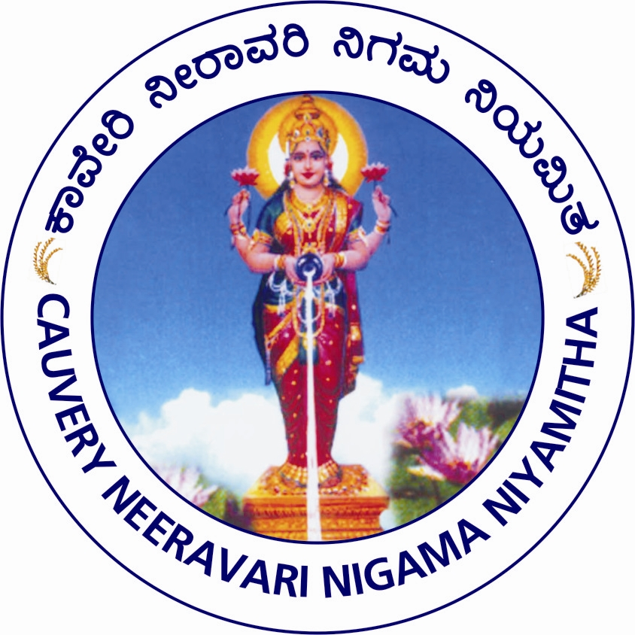
No.2 HRBC Div. Hunsur/ PB-1/ Short Term Tender No.8/ 2022-23/ Dated:
(PÀ£ÁðlPÀ ¸ÀPÁðgÀzÀ MAzÀÄ GzÀåªÀÄ)
Short Term Tender Notification No.: 08/2022-23, Dated: 27-03-2023
(Two Cover System, Through e-Procurement Portal Only)

Percentage rate tenders are invited on e-Procurement basis by the Executive Engineer, CNNL, No.2 Harangi Right Bank Canal Division, Hunsur, Mysore District on behalf of the Managing Director, CNNL, Bangalore from eligible contractors for Scheme to lift water from Lakshmanathirtha River near Mardur Village to fill 49 dry tanks for drinking water purpose in Hunsur & H.D Kote Taluk of Mysore District (on Turnkey basis). Amount put to tender is Rs.6862.17 Lakhs, EMD amount Rs.68.62 Lakhs. The contractors can have access/ download e-Procurement tender document from 30-03-2023 at 11.00 AM onwards and last date to submitt the filled tender document is 24-04-2023 till 4.00 PM. Technical bid will be opened on 25-04-2023 at 4.00 PM onwards and Financial bid will be opened after approval of the Technical Bid. All the information is available on e-Procurement portal web-site address http://eproc.Karnataka.gov.in. Tender processing fee as stipulated in the e-Procurement portal is applicable for works and stipulated period for completion of the work is 18 months (Including Monsoon). Additional information can be obtained from the undersigned during office hours.

Executive Engineer,
Cauvery Neeravari Nigama Niyamita,
No.2 Harangi Right Bank Canal Division,
Hunsur, Mysore District - 571105

