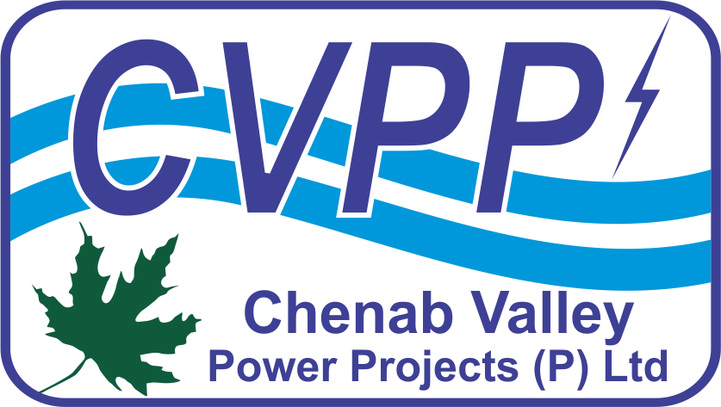**CHENAB VALLEY POWER PROJECTS [P] LIMITED**

A Joint Venture of NHPC Limited (A Govt. of India Enterprise) & JKSPDC (A Govt. of J&K Enterprise)

Chenab Jal Shakti Bhawan, Opposite Saraswati Dham, Rail Head Complex, Jammu -180012 (J&K), India. CIN: U40105JK2011PTC003321; website: [www.cvppindia.com](http://www.cvppindia.com)

# NOTICE INVITING TENDER (PRESS NOTICE)

**E- Tender ID No.: CVPPPL/22-23/ET/1**

**NIT No.: CVPP/KWAR/E&M-PKG/2022 Date: 07.12.2022**

Online bids are invited for and on behalf of Chenab Valley Power Projects [P] Ltd., on International Competitive Bidding (ICB) basis for “**ELECTRO-MECHANICAL (E&M) WORKS PACKAGE (LOT-III) of KWAR HE PROJECT 540 MW, KISHTWAR DISTRICT OF UNION TERRITORY OF J&K, INDIA**”. Bidders shall register themselves on the MSTC website to download and submit their bids. Detailed NIT can be viewed at [www.cvppindia.com](http://www.cvppindia.com), <https://eprocure.gov.in/epublish/app> & <https://www.mstcecommerce.com/eprochome/cvpppl/>. Deadline for submission of online bid is 25.01.2023 (1500 Hrs).

**General Manager (Contracts & Procurement)**

Email: [cont.proc@cvppindia.com](mailto:cont.proc@cvppindia.com)