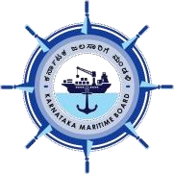

**Karnataka Maritime Board,**

**Government of Karnataka**

“Development of an All-Weather Deepwater Greenfield Port at Keni on Public Private Partnership (PPP) - Design, Build, Finance, Operate, Transfer (DBFOT) Model”

(Tender No: KMB-134/WKS-II/2022/CALL-2)

Karnataka Maritime Board invites proposal from established players in the Ports & Maritime Sector to setup greenfield Ports at Keni (Lat:14041.5’N Long: 740 11.6’E). For detailed Request for Proposal, Project Information Memorandum and Draft Concession Agreement, Please visit Karnataka e-Procurement website: <https://eproc/karnataka.gov.in/>.

**-sd-**

**Chief Executive Officer, Karnataka Maritime Board**