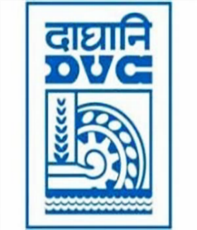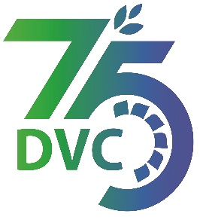**damaooadr GaaTI inagama**

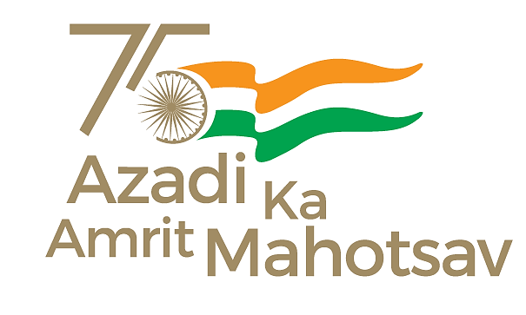

Damodar Valley Corporation

संविदाऔरसामग्रीविभाग

**Contracts and Materials Department**

डीवीसीटावर्स;तृतीयतल;वीआइपीरोड;कोलकाता-७०००५४टेलीफ़ैक्सन०-०३३-२३५५-२९३६

**DVC Towers; 3rd Floor; VIP Road, Kolkata – 700054 Tele fax No.-033 – 2355 –2936.**

**E-Tender Notice**

Damodar Valley Corporation invites Expression of Interest (EoI) from the eligible bidders for:

|  |  |  |
| --- | --- | --- |
| REFERENCE NO. | Description of item | Tender Downloading Period and Time |
| **DVC NIT NO:**- DVC/Tender/Head Quarter/OS & U /CMM/Supply/00038 **dated 04/08/2022.** ***************************  CPPTender ID**:-  2022_DVC_124810_**1 | Expression of Interest (EOI)for Selection of vendors for supply of Conveyor Belts at different power stations of DVC | From 11:00 Hrs. of 05/08/2022  up to 11:00 Hrs. of 03/09/2022 |

For further details and to participate in tender, please log on:

<https://etenders.gov.in/eprocure/app>

Note: For any Technical Queries call:-**0120-4200 462, 0120-4001 002, 0120-4001 005,**

**0120-6277 787.**

**E-Mail Support:Technical - support-eproc(at)nic(dot)in**