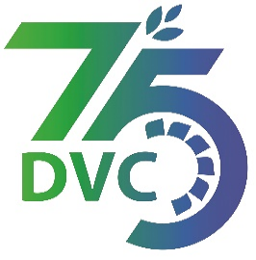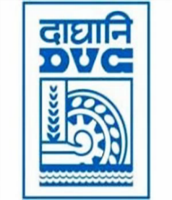 **damaooadr GaaTI inagama**

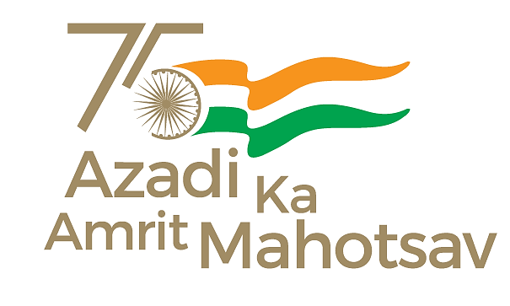

Damodar Valley Corporation

संविदा और सामग्री विभाग

**Contracts and Materials Department**

डीवीसी टावर्स; तृतीय तल; वीआइपी रोड; कोलकाता-७०००५४ टेली फ़ैक्स न०-०३३-२३५५-२९३६

**DVC Towers; 3rd Floor; VIP Road, Kolkata – 700054 Tele fax No.-033 – 2355 –2936.**

|  |  |  |
| --- | --- | --- |
| **DAMODAR VALLEY CORPORATION**  **Contracts and Materials Department**  **DVC Towers; 3rd Floor; VIP Road, Kolkata – 700054**  **Tele fax No.-033 – 2355 –2936.** | | |
| **NO.** DVC/Tender/Head Quarter/FUEL/CMM/Supply/00016/Capital Dated 23/03/2023 | | |
| **E-TENDER NOTICE**  **“THROUGH GeM PORTAL ONLY”**   |  |  |  | | --- | --- | --- | | **Sl. No.** | **NIT No. & Description of Work** | **Tender Downloading Time & Period** | | 1. | **NIT No. :** **GEM/2023/B/3280827 dated 23/03/2023**  **Description :** Procurement of two (02) nos. of BOBRNHSM1 rakes along with two (02) nos. of BVCM for coal supply to MTPS, DVC | From 16:00 hrs of 23/03/2023 to 11:00 hrs of 20/04/2023 | | For further details and participate in the tender, please log https://gem.gov.in/  or www.dvc.gov.in [For view only]  for any help regarding the above tender contact to  GeM Customer care at <https://gem.gov.in/contactUs> | | | | | |
|  |