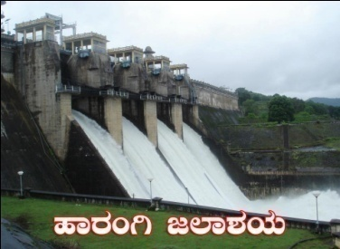 | Cauvery Neeravari Nigama Niyamitha  (Government of Karnataka Undertaking)  Office of the Executive Engineer,  No.2, Harangi Right Bank Canal Division, Hunsur,  MysoreDistrict-571105  ( 08222-252211 Fax: 252211 *eeharangi@yahoo.co.in | 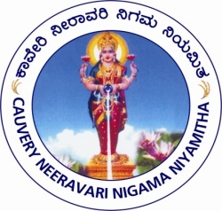

SHORT TERM TENDER NOTIFICATION NO:03/2023-24, Dt: 25-01-2024.
(Through Karnataka Public Procurement Portal Only)

Percentage Rate tenders are invited on Karnataka Public Procurement Portal basis by the Executive Engineer, No.2, Harangi Right Bank Canal Division, Hunsur Taluk, Mysore District on behalf of the Managing Director, CNNL, Bangalore from eligible contractors for the following work. "SCHEME TO LIFT WATER FROM LAKSHMANATHIRTHA RIVER NEAR MARDUR VILLAGE TO FILL 49 DRY TANKS FOR DRINKING WATER PURPOSE IN HUNSUR & HD KOTE TALUK OF MYSORE DISTRICT" (On Turn key basis) Approx. amount put to tender Rs. 7048.60 lakhs, EMD Rs. 70.50 Lakhs. The contractors can have access/download e-procurement tender document from 25-01-2024 onwards and last date to submitt the filled tender document is 05-02-2024 till 4.00 PM. Technical bid will be opened on 06-02-2024 at 4.30 PM onwards and Financial bid will be opened on after Approval of the Technical Bid. All the information is available on Karnataka Public Procurement Portal web-site address https://kppp.karnataka.gov.in/kppp Tender processing fee as stipulated in the Karnataka Public Procurement Portal is applicable for the work and stipulated period for completion of the work is 18 months (including monsoon). Additional information can be obtained from the undersigned during office hours.

Executive Engineer,
No.2, Harangi Right Bank Canal Division,
Cauvery Neeravari Nigama Niyamitha,
Hunsur, Hunsur Taluk,
Mysore District – 571105, Karnataka

