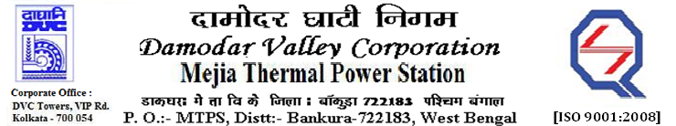

**Phone No.: 03241**- **263038** **FAX: 03241-262287**

**E-Tender Notice**

Damodar Valley Corporation invites online bids with On-line reverse auction (RA) from eligible bidders for:

|  |  |  |  |
| --- | --- | --- | --- |
|  | NIT No. | Description of Job (s) | Tender Downloading Period & Time |
| 1. | MT/O&M/QSF-05-06-10/22-23/VV(212)/115 dtd. 01/08/2022 | Annual Rate Contract (ARC) for Rewinding & Repairing/ Overhauling of damaged 3 Phase, 415 V LT Motors between 16 KW to 187 KW, Dual speed 415 V AC Motors, 220 V DC Motors and Auxiliary Transformers of the sections ES-III, ES-I, CHES-I, OFES-I of U#1-6 and CHP(E) U#7&8, MTPS, DVC | From 19.00 Hrs. of 02.08.2022 to 11.30 Hrs. of 31.08.2022 |

For further details and to participate in the tender, please log on to DVC Website [www.dvc.gov.in](http://www.dvc.gov.in), and <https://etenders.gov.in/eprocure/app>.

Note: e-procurement Helpdesk No. 9831683690 / Mob:8240124812 may please be contacted.

Your faithfully,

-sd-

Shri P.K. Ghosh

SE (Tech), MTPS (O&M), DVC,

[pradip.ghosh@dvc.gov.in]